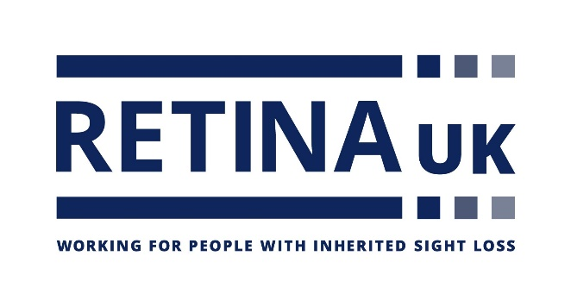

Job Title: Senior Research Coordinator

Hours: 35 hours per week (part time considered)

Salary: £33,000 per annum (prorated for part time)

Department: Research

Accountable to: Research Director

Location: Flexible working location is available with attendance at Buckingham office at least monthly. However, it is a requirement of employment that the post-holder be prepared to work at any additional or different location as may be necessary.

About the Charity:
Retina UK is a national charity that funds cutting edge research into inherited sight loss conditions and offers dedicated support and information to the thousands of people living with these conditions.

Our values:
These values represent how we behave and work together:
Approachable: We are respectful, caring and considerate
Honourable: We are open, professional and act with integrity
Collaborative: We value all those who support us
Ambitious: We are innovative, passionate and always do our best.

Main purpose of the role:

The Senior Research Coordinator supports and assists the Research Director in developing all aspects of Retina UK’s research-related activity.

Key responsibilities include ensuring effective communication of research into inherited sight loss, including the projects we fund, to our community, fundraisers, supporters and staff and measuring the impact of our research programme.

The Senior Research Coordinator will carry out horizon scanning activity and will work alongside the Research Coordinator to write research-related stories for publication across all communication channels. They will be responsible for ensuring that research-related queries are dealt with in an accurate and timely manner and will lead efforts to facilitate engagement between our community and researchers.

The postholder will assist with representing Retina UK at relevant events and meetings and will build and nurture relationships with the inherited sight loss research community. There will be some involvement with delivery of the charity’s research grants programme.

Key tasks/responsibilities:
Tasks in the Senior Research Coordinator’s remit include, but are not limited to:

1. Support the charity’s research grants process alongside the Research Director and Governance Lead.

2. Assist the Research Director with implementing policies and procedures to ensure a robust research grant application process.

3. Horizon scan to highlight recently completed and ongoing clinical trials, research recommendations and new and emerging technologies relevant to our research area.

4. Work with the Research Director to build and nurture relationships with the inherited sight loss research community, represent Retina UK at meetings with researchers, regulatory bodies, other charities, industry, donors and funders, and occasionally attend relevant conferences and networking events to raise the profile of Retina UK.

5. Work with the Research Coordinator to create research-related content (audio, video copy and images) for our website and social media channels on a regular basis, and to write research-related news stories for publication across our communications channels and source relevant images.

6. Provide support to the Research Coordinator to create a bank of research-related images and case studies, ensure relevant permissions are sought and recorded, and ensure this is accessible for staff.

7. Lead the development and organisation of related sessions for Retina UK face to face and online events, with support from the Research Director and the Research Coordinator.

8. Work with the Information & Support team on the development of any research or clinical related information resources.

9. Support the Research Director in measuring the impact of Retina UK’s research-related activity.

10. Work closely with the Fundraising Team to provide updates on research projects to support funding bids and updates for supporters, including major donors and corporates. Aid the Research Director and the Income Generation team in developing compelling research narratives and cases for support.

11. Work with the Research Coordinator to facilitate and promote opportunities for engagement between our community, researchers and industry. This includes management of our community research grant review panel.

12. Inform staff and volunteers about our research activity, including providing updates for staff meetings and our staff newsletter.

13. Support with, and respond to research-related enquiries, working closely with the Research Coordinator, information and support volunteers and staff.

14. Complete other reasonable tasks requested by the Leadership Team or Board of Trustees that are commensurate with the post.

15. To be competent in the use of the charity’s database to fulfil your job role and to maximise efficiencies.

16. To be aware of GDPR regulations and ensure, with training, that you are working within these guidelines.

Person specification:
E = Essential D = Desirable

Experience:
Excellent written and verbal communication skills E
Communicating science for a lay audience E
Working in partnership with other organisations D
Working in a medical research setting D
Presentation skills D

Communicating with communities affected by disability or
chronic illness D

Qualifications/knowledge
Educated to degree level in a biomedical or clinical science E

Planning and analysis
Able to generate clear reports and recommendations E
Excellent IT skills (Word and Excel and PowerPoint) E
Experience of using a database D

Personal qualities
Confident and able to interact effectively and empathetically with
people at all levels, including those with a visual impairment E
Self-motivated and able to plan and manage a high workload E
Able to work to deadlines E
Flexible team player E
Excellent attention to detail E

Commitment
Empathy with Retina UK’s aims and objectives E
To live Retina UK’s values E
Willingness, and ability, to travel E
Able to work in the evenings and weekends when necessary. E

