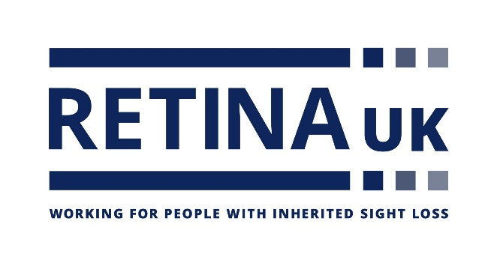

**Job Title:** Income Generation Administrator

**Hours:** 35 hours per week

**Department:** Income Generation Team

**Salary:** £28,665 per annum

**Accountable to:** Head of Income Generation

**Location**: Buckingham office.

**About the Charity:**

Retina UK is a national charity that funds cutting edge research into inherited sight loss conditions and offers dedicated support and information to the thousands of people living with these conditions.

**Our values:**

These values represent how we behave and work together:

* **Approachable:** We are respectful, caring, and considerate
* **Honourable:** We are open, professional and act with integrity
* **Collaborative:** We value all those who support us
* **Ambitious:** We are innovative, passionate, and always do our best.

**Main purpose of the role:**

* To support, develop and coordinate a variety of areas of activity within the Income Generation team.

**Key responsibilities:**

* Assist with the administration and stewardship of supporters across the various income areas and maintain and improve supporter retention and engagement. Areas to support with will include: Community Fundraising, Trading, Challenge Events, Lottery, Legacies and Major Donors.
* Provide an exemplary stewardship programme for existing supporters whilst also developing new ideas to engage new supporters.
* Utilise the charity database, carry out regular analysis, generate reports as requested, ensure records and folders are accurate and up to date and provide regular feedback to the Head of Income Generation.
* Conduct regular supporter research, as requested, to ensure Retina UK remains innovative with its fundraising activities.
* Support with updating the database and printing letters for the Trusts, Foundations and Corporates proposals, reports and thank you letters.
* Ensure that our webpages are regularly updated with new events, ways of getting involved, photographs, case studies and impact quotes.
* Liaise with venues, supporters, exhibitors and attendees ahead of fundraising events and activities, including our Conferences, Sight Village and key challenge events, including London Marathon.
* Thank supporters in the appropriate manner and update and refresh supporter letter templates quarterly to effectively communicate the value of donor contributions. Mix up our thanking methods – calls, letters, emails – as appropriate.
* Take a proactive approach in guiding supporters and potential fundraisers on how they can be involved with Retina UK. Offer clear advice on fundraising opportunities and ensure incoming enquiries are directed to relevant activities that align with their interests and needs, by staying up to date on our products and ways they get can involved.
* Work collaboratively to maintain an efficient and practical administrative process and arrange, attend and take minutes at Income Generation team meetings as and when required.
* Any other duties as reasonably requested by the Head of Income Generation, Senior Management Team and Chief Executive.

**SPECIFICATION:**

**E = essential D = desirable**

**Skills & Experience**

**Minimum of 1 year working in a similar role E**

**Working in a small team D**

**Educated to ‘A’ level standard or commensurate experience E**

**IT literate and highly adept in the use of MS Office Suite E**

**Familiar with email and internet E**

**High standard of written and verbal English and grammar E**

**Database experience E**

**Personal Attributes**

**Confident, polite and cheerful telephone manner E**

**Quick learner able to act on initiative and in the absence of managers E**

**An eye for detail and a flair for organisation E**

**Ability to empathise with people with disabilities (particularly visual impairment) E**

**Able to manage a busy workload E**

**Commitment**

**Empathy with Retina UK’s aims and objectives E**

**Willing to live Retina UK’s values**  **E**