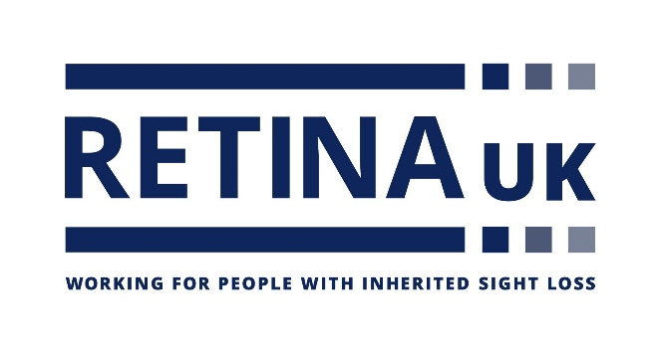

**Job Title:** Campaigns Coordinator

**Hours:** 35 hours per week

**Salary:** £28,665 per annum

**Department:** Income Generation Team

**Accountable to:** Head of Income Generation

**Location**: Remote (with office visits as and when required)

**About the Charity:**

Retina UK is a national charity that funds cutting edge research into inherited sight loss conditions and offers dedicated support and information to the thousands of people living with these conditions.

**Our values:**

These values represent how we behave and work together:

* **Approachable:** We are respectful, caring, and considerate
* **Honourable:** We are open, professional and act with integrity
* **Collaborative:** We value all those who support us
* **Ambitious:** We are innovative, passionate, and always do our best.

**Key responsibilities:**

* Lead on our annual campaigns and appeals, including the Big Give match funding campaigns, our Christmas Appeal and our 50th Anniversary £250,000 appeal, ensuring our appeals stay relevant, ambitious and human. Grow and refresh our appeals year on year.
* Identify and nurture donor relationships throughout the year in anticipation of our appeals, including sourcing pledgers for our Big Give campaign.
* Lead on and develop our annual Raffle, including sourcing a prize sponsor so we can maximise our return. Explore a summer Raffle to tie in with our 50th Anniversary and be drawn at our Annual Conference.
* Introduce and develop new campaigns and appeals throughout the year, including maximising relevant awareness days and months.
* Enhance our digital fundraising offering and introduce new, effective regular digital campaigns to grow our online presence and donations, through engaging content, targeted advertising and Google Analytics.
* Develop our annual thankathon, using our latest Impact Report to showcase the charity’s output – keeping our supporters engaged, informed and appreciated.
* Create compelling and detailed campaign plans with key timelines, targets and set up regular working group meetings to stay on track.
* Produce post-campaign reports to analyse the impact, successes and improvement opportunities. Seek feedback from those involved and schedule in debrief meetings with the working group to present the report’s findings.
* Work with the Communications team and Head of Income Generation to create relevant webpages, case studies, news stories and social media content for the campaigns.
* Collaborate with other internal teams to keep colleagues informed, including our office-based colleagues, our Finance team, our Communications team and our Information and Support team. Keep staff updated through emails, team meetings and regular conversations and meetings.
* Any other duties as reasonably requested by the Head of Income Generation, Senior Management Team and Chief Executive.

**SPECIFICATION:**

**E = essential D = desirable**

**Skills & Experience**

**Minimum of 1 year working in a similar role E**

**Working in a small team D**

**Educated to ‘A’ level standard or commensurate experience E**

**IT literate and highly adept in the use of MS Office Suite E**

**Familiar with email and internet E**

**High standard of written and verbal English and grammar E**

**Database experience E**

**Personal Attributes**

**Confident, polite and cheerful telephone manner E**

**Quick learner able to act on initiative and in the absence of managers E**

**An eye for detail and a flair for organisation E**

**Ability to empathise with people with disabilities (particularly visual impairment) E**

**Able to manage a busy workload E**

**Commitment**

**Empathy with Retina UK’s aims and objectives E**

**Willing to live Retina UK’s values**  **E**