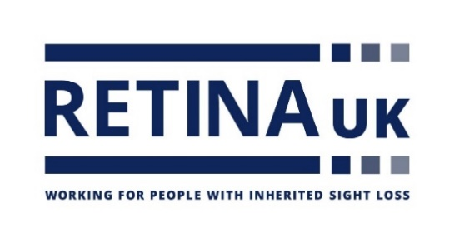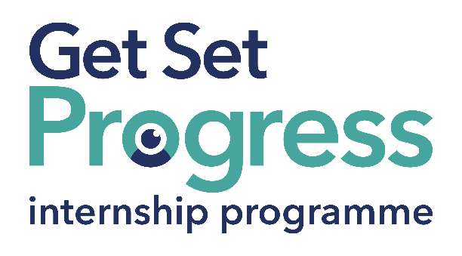

# Fundraising Research & Support Intern

## Join us at Retina UK

Thomas Pocklington Trust (TPT) and RNIB are collaborating with organisations from both the sight loss and wider charity sector as well as corporate organisations to create new opportunities for blind and partially sighted people to find employment through the Get Set Progress (GSP) Internship programme. Retina UK is delighted to be offering an internship as part of the Get Set Progress scheme.

Retina UK is a national charity supporting people affected by inherited sight loss and investing in medical research to help make their challenges a thing of the past.

## Our Values

These values represent how we behave and work together:

**Approachable:** We are respectful, caring and considerate

**Honourable:** We are open, professional and act with integrity

**Collaborative:** We value all those who support us

**Ambitious:** We are innovative, passionate and always do our best.

## What are the benefits of a Get Set Progress internship for me?

As part of your 9-month internship, you will be part of a large cohort of fellow interns and gain the following:

* Obtain valuable work experience within the charity sector
* Technology support (Including Microsoft Office) and upskilling opportunities
* Online and in-person Training and development opportunities
* Opportunity to present and network with Senior leaders within the Sight Loss Sector
* Opportunities to build relationships with fellow interns
* A personal mentor offering support, advice and guidance throughout your internship
* Help deliver positive changes for people with sight loss



As part of the GSP Internship programme, you will also be enrolled on the TPT **Works For Me** Employment Programme, where you will gain bespoke employment support, guidance and advice from the TPT Employment Team, some of the skills that you will receive support and guidance around include:

* CV writing
* Job searching
* Cover letter and speculative letter writing
* Application form writing
* Interview techniques

Job description

Role: Fundraising Research & Support Intern

Department: Fundraising

Reporting to: Head of Fundraising

Location: Hybrid, with occasional travel to our Buckingham Office

Salary: Based on the [Real Living Wage](https://livingwage.org.uk/)

Contract type: Fixed term – 9 months, full time – 35 hours a week.

## Job Specification Information

**Job purpose: Overview of the role:**

We are seeking a motivated and enthusiastic Fundraising Intern to join our team. The intern will assist in various fundraising activities, including donor communications, event planning, funding research, and administrative support. This is a fantastic opportunity to gain hands-on experience and contribute to meaningful projects that directly support our mission.

**Key areas of responsibility:**

* Prospect Research:
* Conduct in-depth research on potential individuals, corporations, interested in funding.
* Analyse and compile data to identify high-potential prospects.
* Data Analysis:
* Assist in analysing fundraising data to identify trends and opportunities specific to funding.
* Maintain and update funding information.
* CRM data analysis - support HoF with segmentation of data, identifying mid-level donors.
* Research Communication:
* Curate content for FR comms newsletters, updates, and reports to keep donors informed about progress and their impact.
* Assist in creating presentations and materials for donor meetings.
* Administrative Support:
* Assist HoF in preparing detailed reports on research fundraising activities and outcomes.
* Handle other research-specific duties as assigned.

**Personal specification - Essential criteria:**This post has a Genuine Occupational Requirement that the successful applicant be a person who is blind or partially sighted, in line with The Equality Act 2010

* Practical IT skills, including MS Office
* Experience in using email and social media platforms
* Excellent standard of written and verbal English, punctuation and grammar
* Understands the importance of accuracy with an eye for detail
* Able to communicate in a friendly and confident manner
* Excellent listening skills
* Flexible regarding tasks and willing to work event hours when required
* Ability to work independently and as part of a team.
* Passionate about Retina UK
* Willingness to travel to the TPT Hub in London for intern development events throughout the course of the internship programme (costs covered by TPT).
* Having **not** previously undertaken the Get Set Progress internship programme.

## What to do next

To request an application pack please email [Miranda.Rodrigo@RetinaUK.org.uk](mailto:Miranda.Rodrigo@RetinaUK.org.uk)

## **Closing date**

Friday 23 August by 17:00

## About Retina UK

Retina UK is a registered Disability Confident Employer (DCS014543 Level 2) and an RNIB Visibly Better Employer.