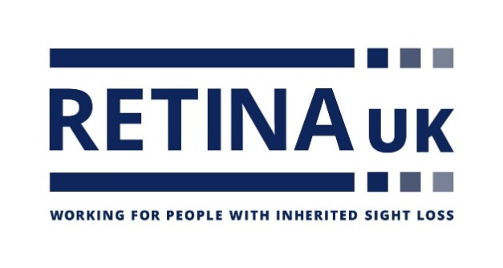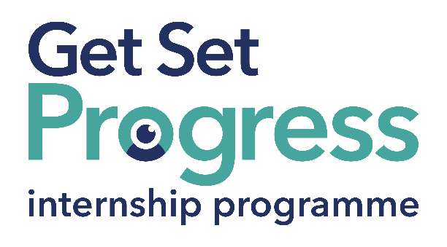

# Development Team Intern

## Join us at Retina UK

Thomas Pocklington Trust (TPT) and RNIB are collaborating with charities in the sight loss sector to create new opportunities for blind and partially sighted people to find employment through the Get Set Progress Internship programme. Retina UK is delighted to be offering an internship as part of the Get Set Progress scheme.

Retina UK is a national charity supporting people affected by inherited sight loss and investing in medical research to help make their challenges a thing of the past.

## Our Values

These values represent how we behave and work together:

**Approachable:** We are respectful, caring and considerate

**Honourable:** We are open, professional and act with integrity

**Collaborative:** We value all those who support us

**Ambitious:** We are innovative, passionate and always do our best.

## What are the benefits of a Get Set Progress internship for me?

As part of your 9-month internship, you will be part of a large cohort of fellow interns and gain the following:

* Obtain valuable work experience within the charity sector
* Technology support (Including Microsoft Office) and upskilling opportunities
* Online and in-person Training and development opportunities
* Opportunity to present and network with Senior leaders within the Sight Loss Sector
* Opportunities to build relationships with fellow interns
* A personal mentor offering support, advice and guidance throughout your internship
* Help deliver positive changes for people with sight loss

Blue and Teal coloured Works for Me logo featuring a graphic of an eye within the O in 'works'. with employment programme written in smaller letters underneath in dark blue. 


As part of the GSP Internship programme, you will also be enrolled on the TPT **Works For Me** Employment Programme, where you will gain bespoke employment support, guidance and advice from the TPT Employment Team, some of the skills that you will receive support and guidance around include:

* CV writing
* Job searching
* Cover letter and speculative letter writing
* Application form writing
* Interview techniques

The Works For Me team will also continue to support you in finding valuable employment after your time on the GSP internship programme has ended.

Job description

Role: Development Team Intern

Department: Development Team

Reporting to: Deputy Chief Executive

Location: Remote with regular attendance at Buckingham office

Salary: Based on [Real Living Wage](https://livingwage.org.uk/)

Contract type: Fixed term - 9 months, full time - 35 hours per week

## Job Specification Information

**Job purpose: Overview of the role:**The intern will support across the charity’s Development Team which is responsible for information and support services, communications, research development, and volunteering and database development. They will also provide administrative assistance to the Deputy Chief Executive and wider team. This is a broad role that will enable the intern to gain a wide range of experience.

**Key areas of responsibility:**Day to day helpline rota management including organising cover if required for volunteers. Assist with administrative tasks relating to the charity’s Local Peer Support Group Network, including sending our email invitations. Send out CPD certificates to professionals who have completed Retina UK training.

Communications

* Assist with the writing and updating of content for the charity’s website digital and print channels. Assist with day-to-day monitoring and management of social media channels. Interview and record case studies. Assist with planning and creating multi-media communications materials, including video and audio. Maintain the charity’s image library.

Research development

* Respond to researchers who request support with study recruitment. Draft emails to the Lived Experience Panel about participation opportunities, using information and material provided by the researcher. Support with aspects of grant administration e.g. requesting reports and reviews (using templates), compiling scores.

Impact measurement and database development

* Make updates to records on the charity’s database. Assist with the evaluation and impact measurement of all development team-related activity including gathering and recording quantitative and qualitative data.

General

* Set up meetings and manage invitations and responses. Create agendas and take and record minutes from meetings, diary management. Carry out online monitoring and research. Provide support for Retina UK events both in-person and online

**Person specification - Essential criteria:**This post has a Genuine Occupational Requirement that the successful applicant be a person who is blind or partially sighted, in line with The Equality Act 2010

* Practical IT skills, including MS Office.
* Experience of using email and social media platforms.
* Excellent standard of written and verbal English, punctuation and grammar.
* Understands the importance of accuracy with an eye for detail.
* Able to communicate in a friendly and confident manner.
* Excellent listening skills.
* Flexible regarding tasks and willing to work event hours when required.
* Willingness to travel to the TPT Hub in London for intern development events throughout the course of the internship programme (costs covered by TPT).
* Having **not** previously undertaken the Get Set Progress internship programme.

## What to do next

To request an application pack please email [Miranda.Rodrigo@RetinaUK.org.uk](mailto:Miranda.Rodrigo@RetinaUK.org.uk)

Closing date:

Friday 23 August by 17:00

## About Retina UK

Retina UK is a registered Disability Confident Employer (DCS014543 Level 2) and an RNIB Visibly Better Employer.