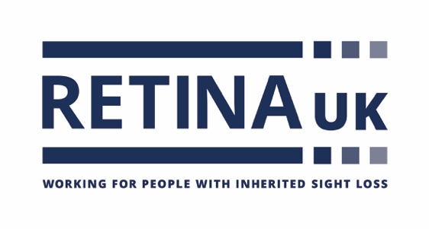

Job Title: Helpline and Information Coordinator

Reports to: Head of Information and Support

Hours: 21 hours per week to include one evening shift per week (up to 8pm)

Location: This role will be home based, with regular attendance at the Buckingham office. It is a requirement of employment that the post-holder be prepared to work at any additional or different location as may be necessary. The post-holder must have access to a private space to receive calls.

About the Charity:
Retina UK is a national charity that funds cutting edge research into inherited sight loss conditions and offers dedicated support and information to the thousands of people living with these conditions.

Our values
These values represent how we behave and work together:
Approachable: We are respectful, caring and considerate
Honourable: We are open, professional and act with integrity
Collaborative: We value all those who support us
Ambitious: We are innovative, passionate and always do our best.

About the role

Our Helpline and Information Co-ordinators are responsible for providing high quality information and practical and emotional support for those living with inherited sight loss, their families and the professionals who support them.

This includes providing a first response and signposting to Retina UK’s volunteer-led information and support services. The post-holder will also create high quality information in a range of accessible formats for our website and other channels.
The purpose of this role is ensure those living with inherited sight loss receive the information and support they need to make informed choices and lead their best lives.

About You

You will be passionate about providing support to people living with inherited, progressive sight loss and their families and be inspired by the potential to make an impact and to deliver tangible change.

You will have helpline, support work or lived experience which evidences your ability to work empathetically with people affected with progressive conditions. You will have strong communication skills, in particular an excellent telephone manner and be a skilled active listener.

Key Tasks / Responsibilities
Tasks in the Helpline and Information Co-ordinator’s remit include, but are not limited, to:

- Provide a first response to callers to the Retina UK telephone helpline, assessing their needs and responding as appropriate.
- Provide active listening, support and information.
- Signpost to Retina UK resources and other Retina UK information and support services, including our talk and support service and peer support groups.
- Where appropriate, signpost on to other relevant external organisations and resources.
- Refer callers to our lived experience helpline volunteers
- Make contact with families referred to Retina UK for support from professionals.
- Maintain appropriate records
- Review existing, and develop new, information resources for those affected by inherited sight loss and the professionals who support them in a range of accessible formats.
- Research and record external information sources relevant for those affected by inherited sight loss.
- Record and evaluate both qualitative and quantitative data to demonstrate the impact of the telephone helpline service
- Deliver services within agreed budget
- Promote our helpline and information and support services throughout our existing network and research other opportunities for promotion.
- Create marketing materials for the helpline and information and support services to be shared through our digital channels, publications and at our events.
- Meet the charity’s duty of care to safeguard and, with training, promote the welfare of those we are in touch with and ensure our safeguarding policies and best practise are followed.
- Be competent in the use of the charity’s database to fulfil your job role and to maximise efficiencies.
- Be aware of GDPR regulations and ensure, with training, that you are working within these guidelines.
- Support the wider work of the charity as we develop resources, projects and programmes to support both our community and professional membership.

Personal Specification:
Information and Support Coordinator
E = Essential D = Desirable

Experience
2 years + working in a helpline role or experience working in health and social care role supporting people with sight loss E
Knowledge and understanding of the sight loss sector D
Working in a small team D
Working with volunteers D
Communicating with a wide range of people E

Qualifications/knowledge
Educated to ‘A’ level standard E

Skills
Excellent telephone manner: skilled active listener with the ability to identify a caller’s needs and respond empathetically E Ability to communicate clearly and effectively with a wide range of people regarding sensitive and/or complex issues E
Cultural sensitivity and awareness E
Practical IT skills, including MS Office and databases E
Ability to store and access data from databases E
Collecting and monitoring data E

Confident in using search engines to retrieve information E

Good organisational skills E

Ability to respect and maintain confidentiality E

Personal qualities
Empathetic and non-judgemental approach to working with service users. E
Emotionally resilient and pro-active in seeking personal support E Confident, polite and cheerful telephone manner E
Able to act on initiative and willing to learn new skills E
A positive, can-do attitude E

Ability to work effectively in a team and as an independent worker E

Commitment
Empathy with Retina UK’s aims and objectives E
Willing to live Retina UK’s values E
Willingness and ability to travel if required E
Able to work in the evenings and weekends when necessary E

Interviews will be held in person on Tuesday 7 and Wednesday 8 May.

