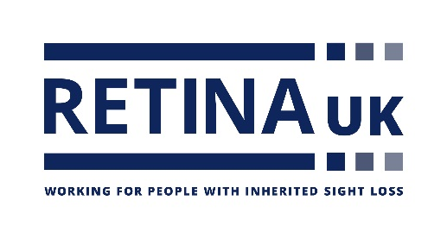

Registered charity 1153851

**Retina UK**

**PROJECT GRANT: PRELIMINARY APPLICATION FORM**

We recommend that this form is completed after reading the relevant sections of the Retina UK website [www.RetinaUK.org.uk](http://www.RetinaUK.org.uk)

**1. APPLICANT (Principal Investigator)**

Please note that CVs will be requested if a full application is invited

**Title:**

**Surname:**

**Forename(s):**

**Post(s) currently held:**

**Institution / Address:**

**Telephone:**

**Mobile:**

**Email:**

**2. CO-INVESTIGATOR (if applicable - will hold equal accountability for the delivery of the proposed research objectives)**

**Title:**

**Surname:**

**Forename(s):**

**Post(s) currently held:**

**Institution / Address:**

**Telephone:**

**Mobile:**

**Email:**

**3. COLLABORATORS (if applicable – will provide a focused contribution for a specific task(s), will serve under the direction of the Lead Applicant)**

**Title:**

**Surname:**

**Forename(s):**

**Post(s) currently held / Institution:**

**Title:**

**Surname:**

**Forename(s):**

**Post(s) currently held / Institution:**

**4. TITLE OF PROJECT**

**5. PROPOSED DURATION**

**6. LAY SUMMARY (100 words)**

**7. DESCRIPTION OF PROJECT (this page maximum, 12 font)**

Briefly describe the project, expected outcomes and translational potential. Please note that this summary will be the basis of the Medical Advisory Board’s decision on whether to invite a full application.

**8. BUDGET (this page maximum)**

Outline the approximate costs under anticipated budget headings each year. These should account for salaries, on-costs, animals, consumables, equipment and inflation. Other costs may be listed but note that institutional overheads will not be paid.

It is highly unlikely that a subsequent full application would be approved if it includes significant costs not outlined here.

**9**. **PREVIOUS RETINA UK FUNDING**

Have you been funded by Retina UK Previously? (previously known as RP Fighting Blindness) YES/NO

If Yes what peer reviewed publications resulted from this funding?