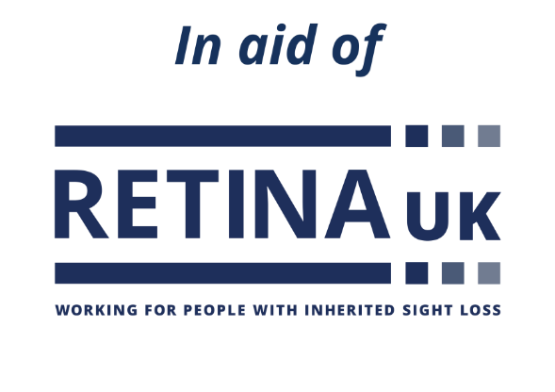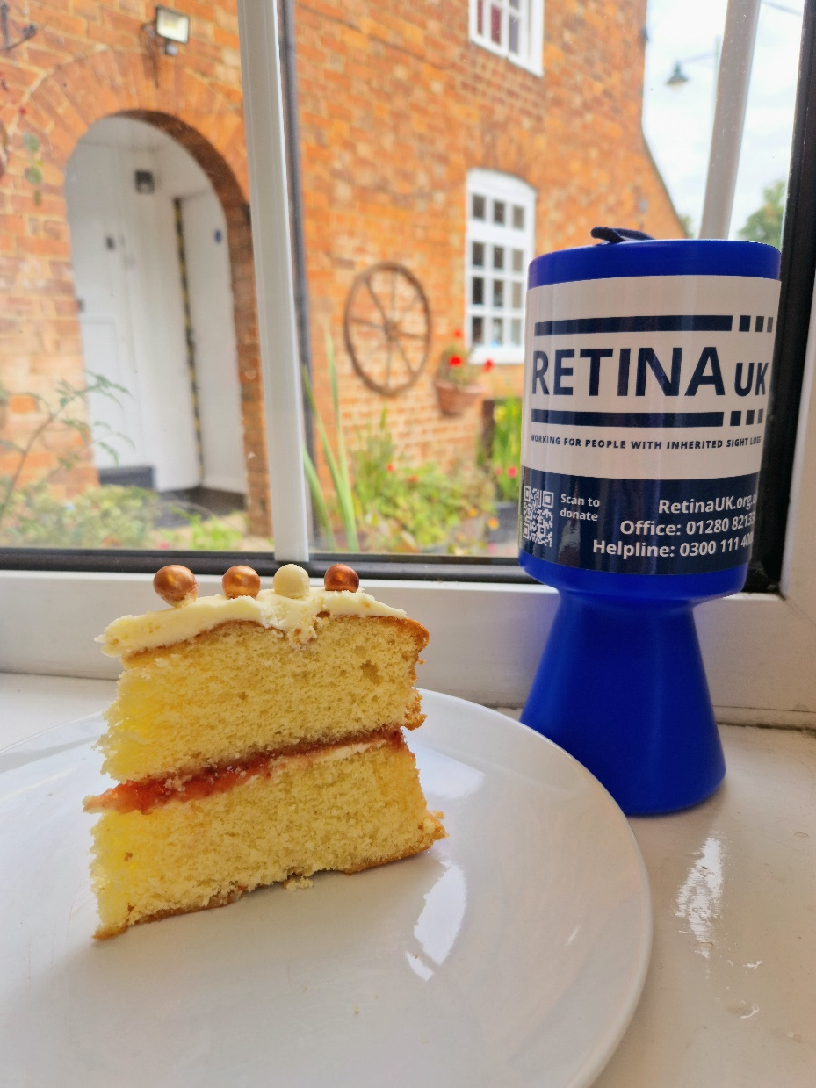

**QR CODE SPACE**

Retina UK is a Charitable Incorporated Organisation, registered charity no. 1153851

 Add your fundraising page URL

**Help xxx to raise   
some dough!**

Use this text box to let people know what you have planned.

**Give your support with every slice**

A donation will mean Retina UK can do more of what they do best - supporting people affected by inherited sight loss to lead better lives today and funding research to accelerate the search for treatments for the future. Donate in the collection box, scan the QR code or visit the link.

**Retina UK’s**

**Great Bake**