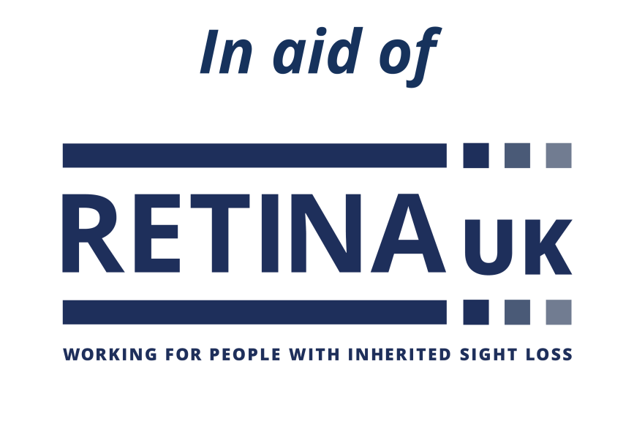

**QR CODE SPACE**

Use this space to add a photo

**Your fundraising title**

Use this text box to let people know what you have planned.

www.justgiving.com/yourURL

**Support Retina UK**

A donation will mean Retina UK can do more of what they do best - supporting people affected by inherited sight loss to lead better lives today and funding research to accelerate the search for treatments for the future. Scan the QR code or visit my fundraising page to donate.

Retina UK is a Charitable Incorporated   
Organisation, registered charity no. 1153851

**Thank you!**