Alpha Research logo 

Working Age Group Project

----

Report on the

Online Consultation

Prepared for:

Retina UK

Prepared by:

Derek Mitchell

Director

Alpha Research Ltd

01844 260248

derek[m@alpharesearch.co.uk](mailto:m@alpharesearch.co.uk)

[www.alpharesearch.co.uk](http://www.alpharesearch.co.uk)

December 2018

# Contents

Background and Objectives - 3 -

Management Summary - 5 -

Findings - 7 -

Diagnosis - 7 -

Continuing in the same post or career - 19 -

Changing Direction - 29 -

Finding, applying for and winning jobs - 37 -

In the workplace - 44 -

Forging a career - 50 -

Services for Employers - 55 -

Summing Up - 62 -

Appendices - 68 -

Appendix 1: Method, Fieldwork and Analysis - 69 -

Appendix 2: Questionnaire - 72 -

Appendix 3: Data for charts - 96 -

# Background and Objectives

The charity Retina UK and its partners commissioned Derek Mitchell from Alpha Research Ltd to undertake research to identify needs for guidance, advice or services that working age people with inherited progressive sight loss would benefit from in their working lives.

The project aims to understand the gaps in service provision. Specifically, the research has explored:

* Signposting to and experiences of employment support upon, or after, diagnosis
* Job choices and retraining
* Navigating job opportunities, interviews and selection processes
* Attitudes of employers and potential employers towards RP and people with RP
* Experiences of Access to Work, assistive technology, advice, networks and support services
* Support services which would have been useful earlier or would be useful now
* Challenges in maintaining employment
* Career progression

Qualitative research in 2017 (group discussions and in-depth interviews) and 2018 (an online forum) was first conducted to gain more clarity on the challenges that people face in continuing to work and progress in a career as their condition develops. These informal, discursive meetings gave people the opportunity to present ideas for services or guidance that might be useful for an agency such as Retina UK to provide.

An earlier paper summarised the findings from the group discussions and depth interviews. The online forum that followed refined some of the findings further, before a questionnaire was prepared to test all the ideas generated.

A consultation was then launched to enable all stakeholders the chance to vote on the ideas that carried the most appeal or utility in their eyes. Links to the questionnaire in HTML and plain text formats were sent out by email in September 2018, to all contacts on the Retina UK database who had agreed to communications. Publicity was also raised through social media and by Retina UK’s partners for this project, the Thomas Pocklington Trust, RNIB and Visionary.

The consultation closed in November 2018 with 171 responses.

This paper presents the findings from the online consultation.

# Management Summary

Without exception, the many ideas generated in the qualitative research were seen as useful by the respondents in this consultation. Of most interest here, however, was with services at the point of diagnosis, particularly on how one’s condition might develop. 10% selected this as their number one priority of all the ideas assessed, more than any other idea tested.

Information, access to and training on Access to Work, assistive technology and *reasonable adjustments*, for both people with RP and their employers, were very much desired too, not only at diagnosis (7%) but also throughout one’s working life (4%).

There was very clear support for Retina UK to work with employers and people with RP to facilitate constructive solutions for both parties, such as adapting the workplace or finding new roles (7%).

Opportunities to learn new skills (4%) and to connect with others with RP to discuss work and career matters (4%) were also held in very high regard.

Along with these overarching priorities, there were other needs which people were very keen for Retina UK to address, relating to particular stages of one’s working life:

* for those in work, specialist advice on employment, along with tailored support and mentoring were priorities, along with guidance on how to talk to your employer about the condition
* for those looking to make a career change, specialist career coaching which takes account of one’s visual impairment and the degenerative nature of RP, along with advice on learning new skills, were seen to be the most useful
* guidance on when and how to disclose one’s condition to current or potential employers was also strongly called for
* for current and prospective employers, raising awareness and understanding of RP and how it can be managed effectively in the workplace (utilising Access to Work, assistive technology and *reasonable adjustments* as necessary) was seen as a real priority
* for those approaching retirement, any help to plan and smooth the transition to finishing work and entering an often daunting new life stage as one’s sight deteriorates, would be very welcome

The comments made by participants in this consultation made it very clear that there is a real hunger for guidance, tools and assistance for people of working age with degenerative sight loss and there is a lot of confidence that Retina UK is the agency to provide these sorts of services.

# Findings

## Diagnosis

The earlier qualitative research had identified six possible resources or services that people with Retinitis Pigmentosa might benefit from. The online consultation asked participants directly how useful each of these might be at the point of diagnosis.

**Summary of main findings**

* All ideas to assist people at diagnosis that were generated in the qualitative research were seen by a clear majority as either extremely useful or very useful
* Of most appeal was having **more information at diagnosis on how one’s condition might develop, in order to inform one’s career and work choices**, with 9 in 10 regarding this as *very* or *extremely useful* and 10% seeing this as the top priority for Retina UK
* practical, realistic, tailored advice suitable for the individual, their family and employers was called for
* **Guidance at diagnosis on how assistive technology and Access to Work can aid employment and work** was almost as popular an idea, with 8 in 10 seeing this as either *very useful* or *extremely useful* and 7% regarding it as the top priority at diagnosis for Retina UK
* raising awareness of available technology or support services, as well as training and resources were desired
* It was also stressed that practitioners need to be fully aware of the distress a diagnosis can cause, meaning that presenting a lot of detailed information may not work at this juncture, so signposting to resources that can be used later on were called for
* Providing access points to RP communities at diagnosis was also important, to enable people to connect, share and learn from others with the condition

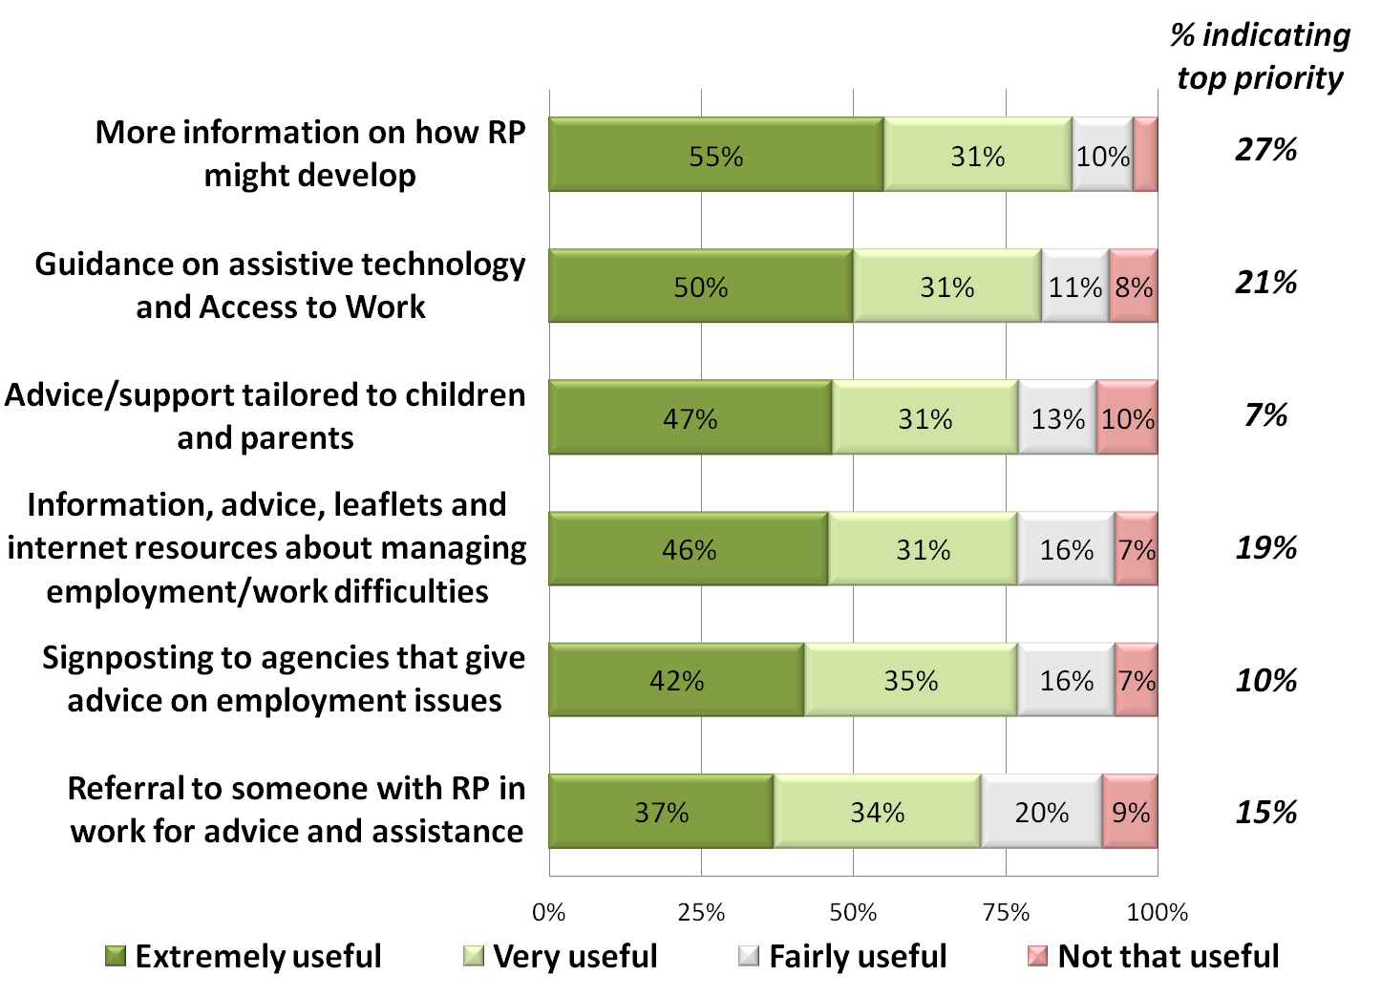

*Figure 1. Q1: Please indicate how useful each of the ideas would be at the point of diagnosis*

All six ideas were regarded by a clear majority of consultation participants as useful, with at least 7 out of 10 in support of each idea. Of the six, there was most support for **more information at diagnosis on how RP might develop, in order to inform one’s work and career choices***,* with nearly 9 in 10 seeing this as at least *very useful* (i.e. rating it as either *very useful* or *extremely useful*). More than half regarded it as *extremely useful*.

* those who have made a career change since they were diagnosed (n=49) were even more likely to say this would have been at least *very useful* (94%), with two thirds (67%) saying it would have been *extremely useful*.

**Guidance at diagnosis on how assistive technology and Access to Work can aid employment and work** was almost as popular an idea, with 8 in 10 seeing this as at least *very useful* and half as *extremely* *useful*.

* younger respondents (16-44 years old, n=42) in particular saw this as at least *very useful* (90%), with just over half (52%) seeing it as *extremely useful*.

The other four ideas were all held in high regard, and this was generally consistent across subgroups. Younger respondents were significantly more likely to rate **advice/support at diagnosis which is tailored to children and their parents** as at least *very useful* (9 out of 10).

Consultation participants were asked to select which one of the six ideas they would recommend that Retina UK prioritises. The top two items mirrored those that were seen as most useful, namely information at diagnosis on how one’s RP might develop (10% selected this as their top priority) and what help can be gained from assistive technology and Access to Work (7%).

The consultation then gave the opportunity to give thought to how the ideas could best be put into practice. 55 people made comment.

(1) In terms of the **provision of information at diagnosis on how RP might develop**, in order to inform one’s work and career choices, the following suggestions were made:

* it was recommended that the information that is given is not just ‘worst case scenarios’, but instead offers practical advice on how to deal with a range of outcomes or potential challenges

**Where are the problems in work going to develop? Identify them and provide the skills to overcome them. Wide remit but motivational**

**Respondent 125**

* this could be tailored to, or combined with, information that can be shared with one’s employer so that they know what to expect and how they can support the employee

**The only thing I was told was that my driving days were numbered so I made dispositions accordingly but with hindsight it would have helped both me and my relatively benign employers if I had been told more about what the future might hold. So at least the issue should be discussed openly with those in work.**

**Respondent 45**

* ideally information should be tailored i.e. take account of the individual’s current job or working status, age and other demographics of relevance
* it was recognised that sometimes at diagnosis it is difficult to take on much information past the immediate diagnosis, so signposting to guidance or support on how one’s condition might develop, that could be explored at a later date, would be helpful

**Some people can manage very well for 20 years following diagnoses without needing any workplace adaptations. If people are not actually experiencing difficulties at the time of diagnosis they may be reluctant to take on board information about what might happen further into the future. In fact this information could be psychologically detrimental if delivered at the wrong time in the disease trajectory. Also there are some people for whom this. Information and support is very relevant but who are not ready to accept help yet. This information could be delivered in a counselling type situation, perhaps a few weeks following diagnoses when the patient has had time to digest the information.**

**Respondent 146**

* providing examples alongside possible prognoses of how others have accommodated their condition in their working lives e.g. by retraining or getting assistance in their job, could also help the individual plan at this stage

(2) With regard to **guidance on assistive technology and/or Access to Work**, the following suggestions were made:

* a need was clearly recognised for raising awareness at diagnosis of available assistive technology and the assistance provided by Access to Work, especially as many respondents said they did not find out about these until later on

**Just letting me know that Access to Work even existed would have been helpful. I struggled for years in a job I loved trying to get around. it was only when I had a referral to OH that they told me about ATW. It has literally revolutionised my home and work life.**

**Respondent 111**

* again, signposting to sources of information or advice would be useful, particularly for those processing a diagnosis who might rather have something to come back to later
* a call for referral to training on, or demonstrations of, assistive technology, ideally from an active user (or at least signposting to such resources)

**During my working life I was never able to gain access to somebody who used to technology in a practical way to understand better how I could implement and use the technology on a practical level. Only by trial and error did I begin to understand the benefits. It would’ve been great to share the experiences maybe a group telephone session or working peoples group even to include recently retired people who have seen technologies change over the years are people who have just left work would be of benefit**

**Respondent 164**

* audio guides (e.g. on CD) of what technology and assistance is available to people with degenerative sight loss
* a note of caution about the limitations of assistive technology in keeping up with computer operating system updates

Respondents were also given the opportunity to say if there was anything else that an agency like Retina UK could provide at the point of diagnosis, and 81 people made suggestions. There were three main themes in evidence:

* the need for psychological and emotional support at the point of diagnosis with RP was stressed, not just for the individual but also their family. This could include access to counselors or life coaches.

**Mental health support advice. Sight loss is a big bad thing, and at some point mental health will be affected as a result**

**Respondent 140**

**Timing is, I feel, key when offering support. Offer ways to get in touch IN THE FUTURE when/if things get worse. Fine to offer advice, leaflets, support at the point of diagnosis, but the most important type of support at the first stage is emotional support. Career support is important for those who are very young - children (for their parents) or very young adults and have time to choose a path that will be compatible with sight loss. But for those who are older when they are diagnosed and already have careers, I feel that the point of diagnosis may not be the right time to start questioning the fact that their jobs are in danger.**

**Respondent 127**

* disseminating details of communities of people with degenerative sight loss, where experiences are shared, participants can provide guidance to or learn from each other

**Peer support is essential so people newly diagnosed don't feel isolated and frightened for the future.**

**Respondent 81**

**'A Weekend Away' for newly diagnosed RP persons and their families will be of benefit to them as they meet and share their experiences**

**Respondent 39**

**Having a network of other people who also suffer from Appey would be useful. Not everything needs to revolve around work sometimes it would just be nice to socialise and meet and chat with someone else going to the same issue**

**Respondent 167**

* information that can be utilised by employers

**For me, the main employment issue is that any potential employer won't understand what RP is or how it affects people who have it. Potentially an employer may be put off employing someone with RP as soon as they ask and find out it involves severe visual impairment. If there was some kind of information leaflet/card that concisely summarised my symptoms and the nature of the impairment then an employer would know what to expect and how to then compensate for any problems. By knowing that RP is an 'official' medical condition employers are more likely to be understanding and not put off employing someone with RP.**

**Respondent 37**

Also suggested by a small number of respondents were the following:

* Information on services local to the individual (not just national organisations)
* Advice on how to talk to your employer or a potential employer about your condition
* Information on research and genetic testing
* Financial or benefits advice
* Information on mobility training
* Access to a telephone helpline that could answer queries later
* Specific advice about making the transition to no longer being able to drive e.g. information on Access to Work, alternative means of travel

## Continuing in the same post or career

At diagnosis many people wanted to stay in their current job if at all possible, and we had identified in the previous research ways in which this could be better facilitated. Six ideas were put to the test.

**Summary of main findings**

* All six proposals to enable people to continue working at their job were seen by a clear majority of respondents as either *extremely useful* or *very useful*
* There was the most enthusiasm for Retina UK to help **facilitate constructive dialogue between employers and their employees with RP** (37% seeing this as the top priority here for Retina UK), to advise on matters such as workplace adaptations or finding new roles
* it was hoped that Retina UK could raise awareness and understanding amongst employers of RP and how it can best be managed in particular work environments
* help to refocus attention on what a person’s capabilities are would be welcome, rather than on any limitations that the condition may impose
* **Specialist advice on employment, along with tailored support and mentoring** were the second priority for those wishing to stay in their job (22%), with 1 in 5 rating this top priority for Retina UK in order to assist those wanting to continue where they are
* it was hoped that Retina UK could give direct advice to employers on the challenges of RP and how these can be best managed in the work environment
* the suggestion was made that Retina UK could become the (degenerative) sight loss specialist employment advice agency in a network of advice agencies
* perhaps Retina UK could identify areas of good practice to help advisors and mentors in their roles
* The importance was also stressed of Retina UK **raising awareness and understanding of Access to Work and assistive technology**, of both employers and employees (17%)

About three quarters (77%) of the respondents wanted to continue in the same post after they had been diagnosed. Most of the remainder (17%) did not know, rather than deciding to leave their job once diagnosed.

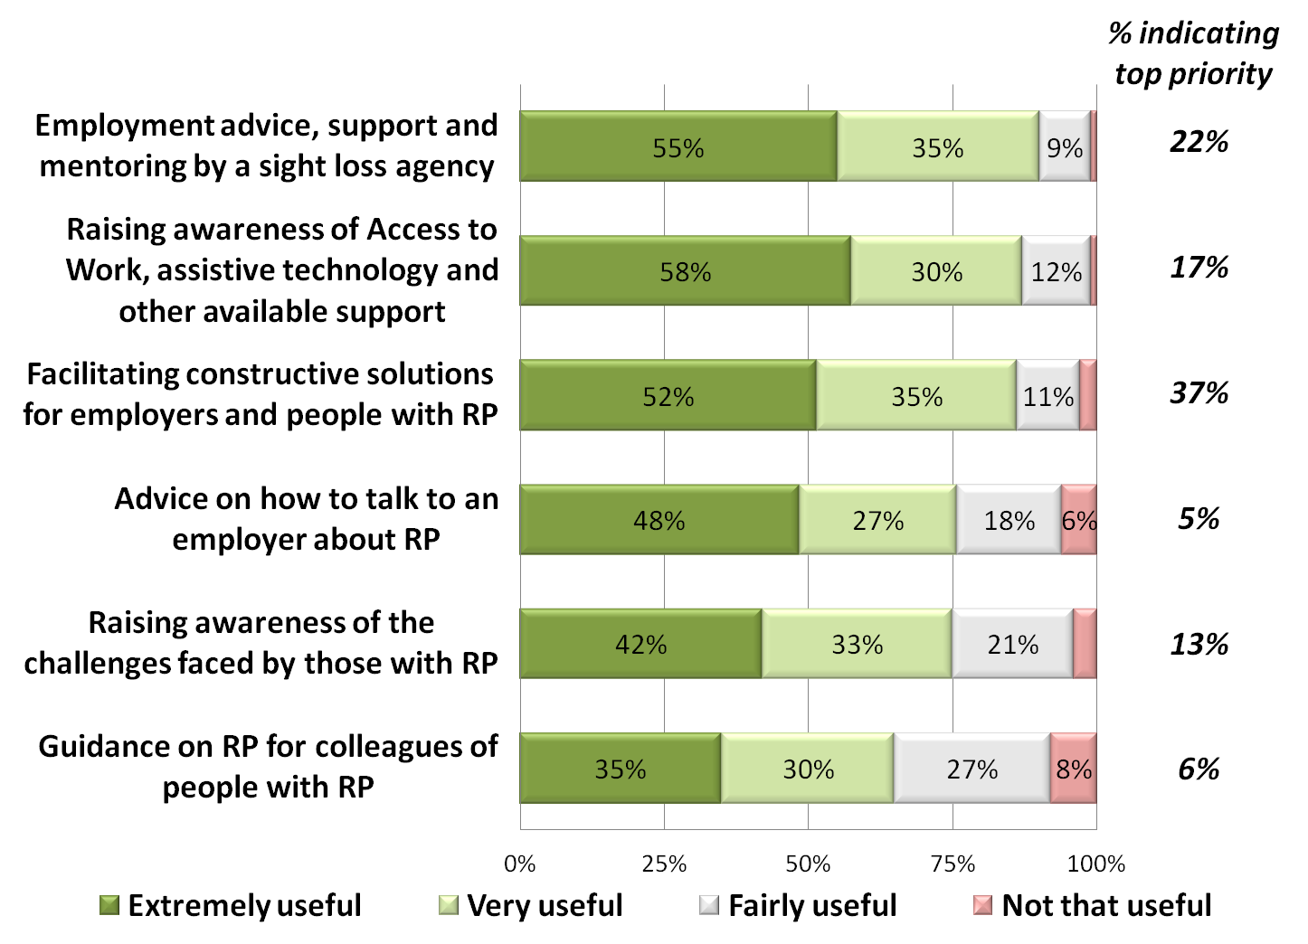

*Figure 2. Q6: Please indicate how useful each of the ideas would be to help people stay in their post once they have been diagnosed*

All six proposals for how to assist people wanting to remain in their job carried significant appeal – they were seen as extremely or very useful by two thirds or more of respondents.

The chart indicates particularly clear support (more than 8 in 10 saying these would be either *extremely useful* or *very useful*) for some or all of the following:

* **Specialist employment advice, support and mentoring for people with visual impairment**
  + especially women, with 96% regarding this as extremely or very useful, compared to 86% of men
* **Raising awareness of Access to Work, assistive technology and other available support** 
  + especially those in the 45-54y. age bracket (94% regarding as very or extremely useful)
* **Working with both employers and people with RP to facilitate constructive dialogue**
* In addition, more than 8 in 10 females were keen for an agency like Retina UK to **raise awareness about the challenges faced by those with RP, or losing one’s sight whilst working**

More than half of respondents thought each of these ideas would be *extremely useful*, with about a further third seeing them as *very useful*. When asked to specify one priority here for Retina UK to address, it was **facilitating constructive dialogue between employers and people with RP** that came out on top – chosen by almost 4 in 10 (37%) of respondents.

* Specialist advice, support and mentoring was seen as the top priority for Retina UK by about 1 in 5 (22%)
* Raising awareness of Access to Work and assistive technology and other available support was seen as the top priority by about 1 in 6 (17%).

There was much consistency between different subgroups here, although it is perhaps of note that those not working were marginally keener on all of the options.

37 respondents took the opportunity to suggest ways in which their priority area could be made to work. For the three most appealing ideas, the suggestions were as follows:

(1) With regard to how Retina UK could help **facilitate constructive dialogue and solutions between employers and employees**, it was clear that a number of respondents had had quite poor experiences with their employer once the condition was disclosed, and they thought that their employer could have benefited from greater understanding of their condition and how it can be managed most effectively in the workplace.

**My experience, when I told my employer was very negative and was off work for nearly two years and has resulted in taking my employer to an employment tribunal. This all could have been dealt with differently if someone like RPFB had been involved from the start.**

**Respondent 53**

It was suggested that:

* Retina UK could work specifically with employers to help them understand what the person with RP might need, what *reasonable adjustments* they may be expected to make and reassure them of assistance that they can seek if needs be. This could include dialogue with line managers, occupational health departments and human resources departments

**For Retina UK to be involved in meetings say with my line manager and HR and occupational health or at least send them advice /info about how to assess the workplace and adapt for those with RP as they really completely lack knowledge**

**Respondent 140**

* Retina UK could help to identify more appropriate roles within a company for someone with RP, if the current role is likely to become challenging as their condition develops
* there was a call for Retina UK to help focus the employer and employee’s minds on what *can* be done by the employee (with the aid of the right technology or funding as necessary) rather than the limitations their condition might impose

**The assistance and advice on what can be done rather than focusing on what has been lost is vital for employers. The employer needs just as much if not more assistance at this point to convince them the employee can remain in work.**

**Respondent 155**

(2) For Retina UK to provide **specialist advice, support and mentoring**, the following suggestions were made:

* direct advice given to employers by Retina UK on the particular challenges faced by people with RP and how to address these

**Employers are often scared that having a disabled person in the workplace will be dangerous or cost them money to make adaptations. They are also often concerned about how the disabled employee will meet their targets and the impact this will have on the business.**

**Respondent 81**

* Retina UK to work in tandem with other advice agencies, to provide a joined up employment advice service where they can provide the specialist expertise on working whilst managing a degenerative sight loss condition
* mentors could be informed of success stories and elements of good practice to put into practice with their mentees

**Tap vast reservoir of members’ experience of both problems faced - and as if not more importantly solutions found to them - to produce guidance for as many different scenarios as possible. Also talk to employers of people with RP to gain comprehensive idea of what they have learned.**

**Respondent 180**

(3) For Retina UK to raise awareness of **Access to Work, assistive technology and other available support** it was suggested that they could:

* advise both employers and workers on these options
* make workplace visits to assess and advise on what aids and assistance could be most useful
* provide training on assistive technology
* assign named advisers to help individuals with choosing aids and assistance and keep them updated of new developments

**Training and support for assistive technology over an extended period - named support worker who could maintain regular contact and be available without recap of position, but be aware of inevitable change/decline in condition.**

**Respondent 152**

Respondents were given the opportunity to make new suggestions for how people with RP could be helped to continue effectively in their work. Most comments here reiterated the need for enhancing the understanding of employers and ensuring that all parties are as aware as possible of what assistance there is. The focus was very much on ensuring the employee can get the most out of their employment whilst the employer benefits from optimum productivity. It was also observed that sometimes the solutions are quite straightforward, once the knowledge is there.

**It all comes down to communication and understanding. If the employee knows exactly what their role is i.e. what the employer requires of them and the employer knows exactly what the employee can and can't do within the confines of having RP, there is a much better chance of finding a compromise whereby the employee can contribute as much as is possible for them and the employer gets as much 'productivity' as possible out of the employee.**

**Respondent 37**

**There is nothing positive about being diagnosed with a condition like RP but people should be given the chance to discuss the issues at work and employers should not let it be seen as something they can ignore (or that will get better). Most of the assistance that is available is not particularly expensive or difficult to acquire and people should not think always in terms of big solutions to big problems. The problems are not necessarily all that big and some of the solutions are easy to find.**

**Respondent 45**

## Changing Direction

Those who have made, or thought about making, a significant change in direction of their career since being diagnosed with RP, were asked their view on how they could be assisted in this. Nine possible ideas had arisen from the qualitative research for the respondents to consider.

**Summary of main findings**

* All nine proposed ideas for people looking to change careers were regarded as either *extremely useful* or *very useful* by more than half of the respondents
* **Career coaching tailored for people with RP** was seen as the top priority for Retina UK to focus on here (25%), and seen as *extremely useful* for half of respondents and *very useful* for a further 3 in 10
* ideally coaching to come from those with RP and in related areas of work
* all channels and media supported for this
* **Advice on planning a career path when you have a *developing* condition** was second priority (18%), viewed as *extremely useful* by 6 in 10 respondents and *very useful* for a further quarter
* group sessions and workshops were suggested
* advice to ideally cover both career options and the logistical issues of the work
* **Advice on what support is available to learn new skills, retrain or go back into education** (14%) was regarded as *extremely useful* for nearly two thirds of respondents, and *very useful* for a further quarter
* it was hoped that this could be provided for both employers and people with RP (both those imminently making a move and those planning ahead for if and when their condition changes significantly)
* again, the input from those with RP in work or training would be invaluable

Amongst the sample, 97 individuals (62%) had either made a career change since being diagnosed with RP (32%) or had thought about making one (29%). Females were significantly more likely to have made a career change (41%).

Those who had changed career or considered doing so were asked their opinion of nine possible ideas, from the qualitative research, which was thought may assist those embarking a career move.

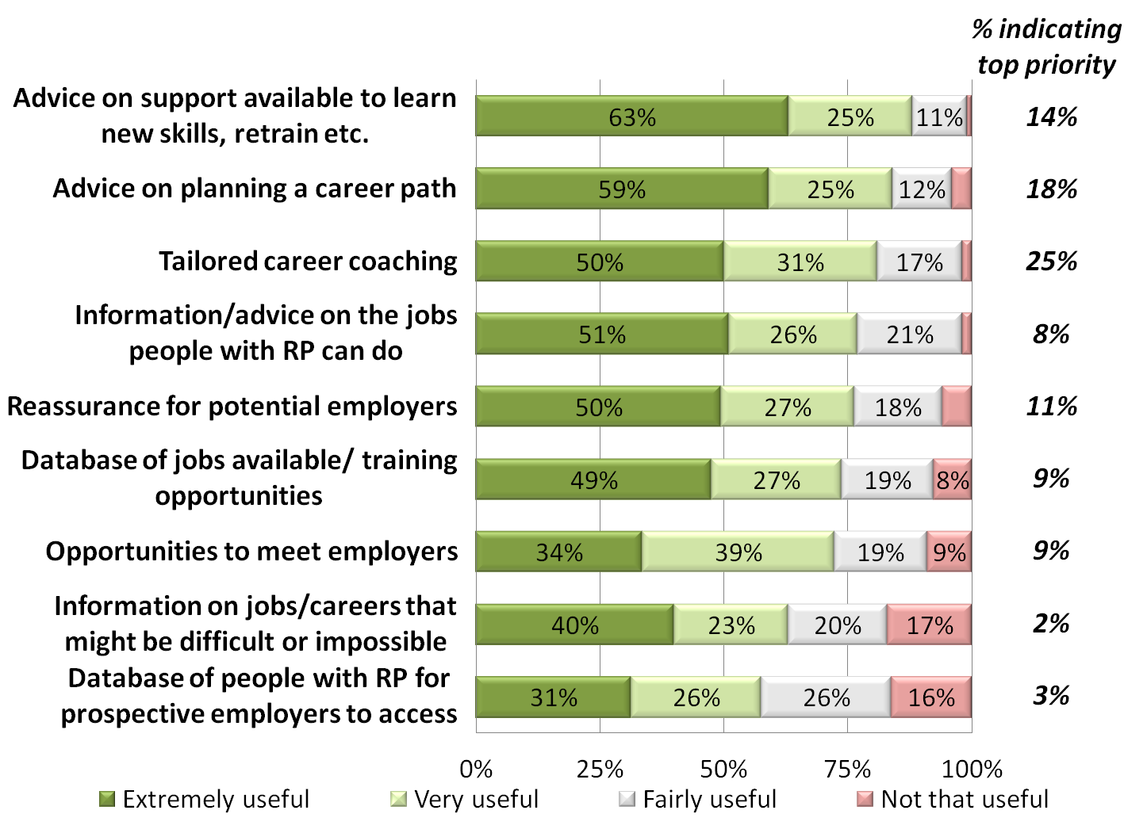

*Figure 3. Q12: Please indicate how useful each of the ideas would be to help people with RP looking to change career direction*

The chart indicates that all nine ideas were regarded as either *extremely useful* or *very useful* by more than half of the respondents. Three ideas were extremely or very useful in the eyes of at least 8 in 10 respondents:

* **Advice on what support is available to learn new skills, retrain or go back into education** was regarded as extremely useful for nearly two thirds of respondents, and very useful for a further quarter
  + especially women, with 95% regarding this as extremely or very useful, compared to 85% of men
* **Advice on planning a career path when you have a *developing* condition** was extremely useful in the perception of 6 in 10 respondents and very useful for a further quarter
* **Career coaching tailored for people with RP** would be extremely useful for half of respondents and very useful for a further 3 in 10
  + a particularly popular idea for those in London (n=31), where 94% regarding as extremely or very useful
* In addition, nearly 9 in 10 of both the youngest (aged 16-44y., n=30) and the oldest (55y.+, n=25) respondents would like **potential employers to be reassured about employing someone with RP** 
  + the youngest respondents were also very keen for there to be a **database of current jobs or training opportunities** available (e.g. 79% saying this would be *extremely useful*)

Given the opportunity to choose just one of these nine ideas as the one which Retina UK should focus on for those looking to make a career move, the same three ideas were most selected:

* The most picked as a top priority was tailored career coaching (25%)
* Advice on career planning for those with a developing condition was the second most selected ‘top priority’ (18%)
* Advice on support for retraining, learning new skills or returning to education was also highly recommended (14%)

No major subgroup differences in priorities were identified here.

Respondents were again asked how best these ideas could be put into practice by an agency like Retina UK. 24 people made suggestions, of which the key recommendations for the three priority areas were as follows:

(1) **tailored career coaching**

* face to face, telephone or online assistance would all be valued
* this could come from those with RP in related work

**It is essential to learn from others who are employed, from employers who have among their staff someone who is blind or visually impaired. That advice can help the candidate know how to shape the conversation with the employer, focus on what they bring to the role, the value to the wider organisation in terms of diversity and how that information and perspective can help the organisation deliver better services to employees and customers.**

**Respondent 175**

(2) **career planning for those with a developing condition**

* it was suggested that this could include Retina UK working alongside agencies such as the JobCentre
* group sessions offering advice and networking opportunities were suggested
* taking into account both suitable careers and logistics of working would be helpful e.g. commuting

**Need to manage the career path possibly without knowing for how long you might be legally able to drive, so may be advisable to 'do it now' rather than wait until it is too late (sight degeneration may be slowly progressive or may happen suddenly). 'Remote working' jobs may seem attractive to move to but can make people feel more isolated and may limit career progression in the 'ladder climbing' sense. Considering the practicalities of getting to/from the workplace are possibly as important as planning the career path itself, so advice would also need to be given on this.**

**Respondent 119**

(3) **advice on support for retraining, learning new skills or returning to education**

* this could be aimed at both the individual and employers
* could include advice or testimonials (or seminars or workshops with) from others with RP who have retrained or who can recommend or explain certain career paths
* could be helpful not only to those looking to make a career change but also for those planning ahead to if and when sight degenerates significantly

**It is very helpful for people with a diagnosis of RP to have a plan B early on in order that new skills and knowledge can be gradually acquired over time in order to ensure a smooth transition into any new career pathway.**

**Respondent 146**

20 respondents made further suggestions for what an agency like Retina UK could provide to help people with RP looking to change career direction. Mentioned more than once were information on or provision of grants for people to retrain, along with guidance on how to move into self-employment.

**Details of or organised trips to careers fairs, details of the types of evening/distance learning classes available to learn appropriate new skills to eventually lead to alternative employment. People need opportunities to discover skills/talents they are unaware they have that may provide a practical living and a continued sense of fulfilment, even with their visual impairment, whilst they still have 'useful' sight for that new kind of work.**

**Respondent 119**

## Finding, applying for and winning jobs

The qualitative research participants proposed six ideas which may be of use to people looking for and applying for new jobs.

**Summary of main findings**

* All six proposed ideas for people looking to find, apply or win new jobs were regarded as either *extremely useful* or *very useful* by more than half of the respondents
* **Raising the awareness of potential employers of the practical and financial support available to employ someone with RP** was regarded as the most important priority here for Retina UK (29%), with more than half seeing this as *extremely useful* and a further quarter seeing it as *very useful*
* assistive technology, Access to Work, and *reasonable adjustments* were the key areas where employers were seen to be less aware
* both telephone and online help were specifically called for
* **If, when and how to disclose one’s condition** was the second highest priority (23%) and viewed as *extremely useful* by more than half and *very useful* by a further 3 in 10
* constructive, positive ways to do this were called for
* providing psychological support for disclosure could also be valuable
* **An indication from Access to Work at the point of applying for a job on what assistance might be funded** was also deemed important - viewed as *extremely useful* by more than half and *very useful* by a further quarter

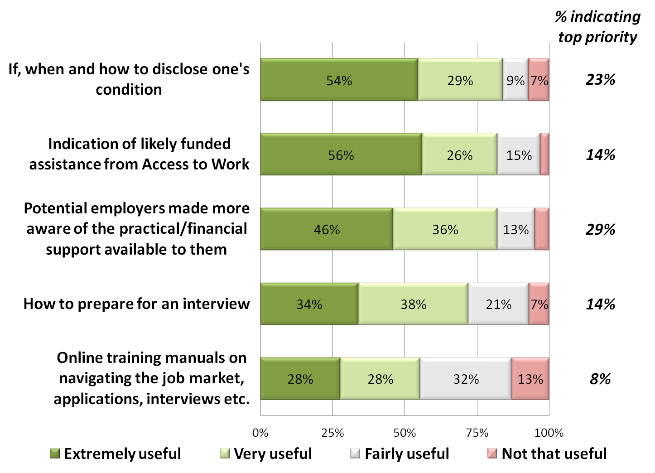

*Figure 4. Q16: Please indicate how useful each of the ideas would be to help people with RP when applying for new jobs or posts*

The chart indicates that all five ideas were regarded as either *extremely useful* or *very useful* by more than half of the respondents. Three ideas were seen as either *extremely useful* or *very useful* by at least 8 in 10 respondents:

* **If, when and how to disclose one’s condition** was viewed as *extremely useful* by more than half and *very useful* by a further 3 in 10
* **An indication from Access to Work at the point of applying for a job on what assistance might be funded** was viewed as *extremely useful* by more than half and *very useful* by a further quarter
  + more than 9 in 10 (92%) females regarded this as either extremely or very useful
* **Raising awareness of potential employers of the practical and financial support available to employ someone with RP** was regarded as *extremely useful* by more than half and *very useful* by a further quarter
  + females particularly supported this idea, with 9 in 10 (89%) regarding it as either extremely or very useful

Thinking about what an agency like Retina UK could provide for people searching and applying for jobs, two of the above were clear priorities:

* Raising awareness of potential employers (29% saw this as the top priority for Retina UK)
  + selected as the top priority by nearly half (48%) of those not currently in work
* Advice on disclosing one’s condition (23%)

There were no subgroups who did not see these two ideas as key actions for Retina UK.

25 people made comment here on how these ideas could be put into action:

**(1) Raising awareness of potential employers of the practical and financial support available to employ someone with RP**

* advice for employers on assistive technology and Access to Work were most called for
* assurance of how *reasonable adjustments* can be straightforward to implement
* provision of a telephone and/or online helpline for employers was called for

**Employers are often discouraged from employing disabled people because they think making reasonable adjustments will be expensive when in fact it might just mean using commonsense to change the content of a job rather than spending thousands of pounds changing a building.**

**Respondent 81**

**Assistive technology is advancing all the time making it more plausible for greater job opportunities. That surely is crucial for those with RP. Hearing aids and loop-systems are advancing too making it good for those with Usher's Syndrome. I regularly attend meetings now and benefit from personal assistance. Sometimes I have a stenographer or note-taker who types on a computer as I read people's speeches and dialogues.**

**Respondent 39**

(2) **If, when and how to disclose one’s condition**

* in particular, guidance on how to disclose RP constructively to an employer was requested
* the potential need for support in making a disclosure was noted

**Disclosure of RP to colleagues and managers is extremely stressful. I hid my condition for many years.**

**Respondent 56**

**Whilst I am not ashamed of my condition, and can do nothing about its progress, it’s not as common as other disabilities and help with the right way to disclose it would be good. Do you just disclose it on the Equality screening form? Bring it up at interview? How do you present it in a positive way?**

**Respondent 173**

(3) There were also a couple of constructive comments about the difference it might make to be able to **consult Access to Work prior to applying or accepting a new job**.

**Access to Work need to be more transparent and showcase how they have and are helping people retain their jobs. It’s as though there is help we can give you - but we’re not telling you everything - what do you want? It’s as though they have a shop with blacked out windows, their products are kept in the stockroom and their staff need to be sent on a product sales course**

**Respondent 27**

**I have sat in an interview (in town A) and wondered how on Earth I would travel to the new job as public transport did not link up. I thought I was being ridiculous even applying. Although I knew about Access to Work, at the time my employer was in town B which I could reach on public transport. They later moved to town A and I had to get assistance from Access to Work in the end. I realised then that I had ruled out a whole raft of jobs. If I had known that I would definitely get travel assistance that would have been very helpful. As it turned out, my employer moved from town A to town B and I did qualify. I realised then that there was a whole raft of jobs I had ruled out "because I couldn't get there".**

**Respondent 57**

19 respondents made other suggestions for services that Retina UK could provide for people when applying for jobs. Raising awareness of both employers and employees was again a central theme, for example to give legal direction on the obligations of employers when employing a person with RP, or encouraging organisations to employ people with RP by certificating the organisation, which can act as favourable publicity.

## In the workplace

We asked respondents to consider what might be useful for people with RP in their current role. Eight ideas had come up from the qualitative research, for which we sought opinion on here.

**Summary of main findings**

* All eight proposed ideas for people in jobs were regarded as either *extremely* or *very useful* by over half of the respondents
* **Advice on how to explain to an employer what you might be needing as your RP develops** was most likely to be selected as the top priority here for Retina UK (26%), and more than half seeing this as *extremely useful* and a further quarter seeing it as *very useful*
* online resources and helplines were requested
* **Advice on technology and assistive technology** was the second most selected top priority for Retina UK (21%), with more than half regarding this as *extremely useful* and a further quarter as *very useful*
* there was a call for this to include ongoing technical support, not just pre-purchase or set up advice
* **Information on how Access to Work works, what it can fund, and how to apply successfully** was the third highest priority (20%) viewed as *extremely useful* by more than half and *very useful* by a further 3 in 10

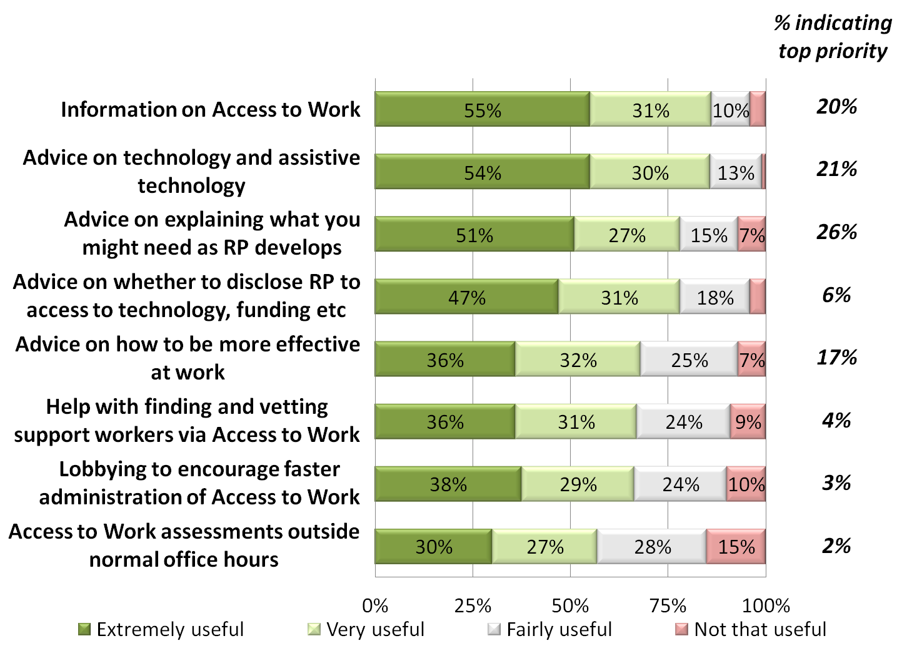

*Figure 5. Q20: Please indicate how useful each of the ideas would be to help people with RP in the workplace, in their existing job*

The chart indicates that all eight ideas were regarded as either *extremely useful* or *very useful* by more than half of the respondents. Two ideas were seen as either *extremely useful* or *very useful* by at least 8 in 10 respondents, and these we have seen before as very important priorities (see *Continuing in the same post or career* chapter), namely:

* **Information on how Access to Work works, what it can fund, and how to apply successfully** was viewed as *extremely useful* by more than half and *very useful* by a further 3 in 10
* **Advice on technology and assistive technology** was also viewed as *extremely useful* by more than half and *very useful* by a further quarter
* In addition, of those not currently working said that **lobbying to encourage faster administration of Access to Work** (88%) and/or **help with finding and vetting support workers via Access to Work** (81%) would be either *extremely useful* or *very useful*

Information and advice on Access to Work and assistive technology was consistently rated very highly by all subgroups.

When asked to select the top priority for those in work for Retina UK to give attention to, these two ideas were again prominent, but they were not the highest priority in the consultation:

* Advice on how to explain to an employer what you might be needing as your RP develops was most likely to be selected as the top priority (26%)
  + and by nearly half (48%) of those not currently in work
* Advice on technology and assistive technology (21%)
* Information on Access to Work (20%)

There were no other significant subgroup differences of note here.

Opportunity was given to comment, and 15 people made suggestions on how these suggestions could best be acted upon by Retina UK:

(1) **advice on how to explain to an employer what you might be needing as your RP develops**

* online resources and helpline facilities (both online and telephone) were suggested

**This could be done via meetings with line manager and HR and occupational health and what would be useful is a form like this so that everyone knows what to expect** [**https://www.merseycare.nhs.uk/media/3404/hr27-v2-supporting-staff-with-disabilities-uploaded-7-jan-17-review-jan20.pdf**](https://www.merseycare.nhs.uk/media/3404/hr27-v2-supporting-staff-with-disabilities-uploaded-7-jan-17-review-jan20.pdf) **Have just given a copy to my HR head to look at.**

**Respondent 140**

**Know how to disclose. Learn key facts about RP. Learn how to talk confidently about your condition and learn how to talk confidently about the value you bring to the workplace. Be a subject matter expert on your condition. Speak with authority on what the condition and what you will do to mitigate the expected changes and then explain to your employer what they can do to assist you.**

**Respondent 175**

(2) **advice on technology and assistive technology**

* preferably to include ongoing technical support once up and running with new technology

(3) **information on how Access to Work works, what it can fund, and how to apply successfully**

**Despite being diagnosed 30 years ago, nobody told me about access to work until 3 years ago. Even then I stumbled across access to work myself. Until then I was continuing to take risks with driving. If only somebody had given me the relevant info.**

**Respondent 56**

When given the opportunity to suggest other services that Retina UK could offer for those in work, 11 people commented – often to reiterate or embellish points already raised. Two people did however stress the need for tailored support, such as mentors able to identify with the individual’s particular needs.

## Forging a career

Participants in the consultation considered progressing in a career and what more people with RP might need to keep their career moving in the right direction. Seven ideas were presented from the qualitative research for participants to consider.

**Summary of main findings**

* All seven ideas were regarded as either extremely useful or very useful by more than half of the respondents
* The idea that was most selected as top priority for Retina UK to focus on here was **guidance on coming to the end of one’s working life e.g. on early retirement, voluntary redundancy, pension planning** (26%)
* retirement can be a daunting prospect if sight is set to deteriorate, so support to plan it effectively would be welcome
* **Greater opportunities to learn new skills in order to keep pace or move to another job or field** was the second highest priority (24%)
* a wider choice of local networks was called for
* **More opportunity for people with RP to connect and discuss work and career matters e.g. at local events or on an online contact network** was third highest priority (20%)
* this could be face to face meetings, online forums or social media groups

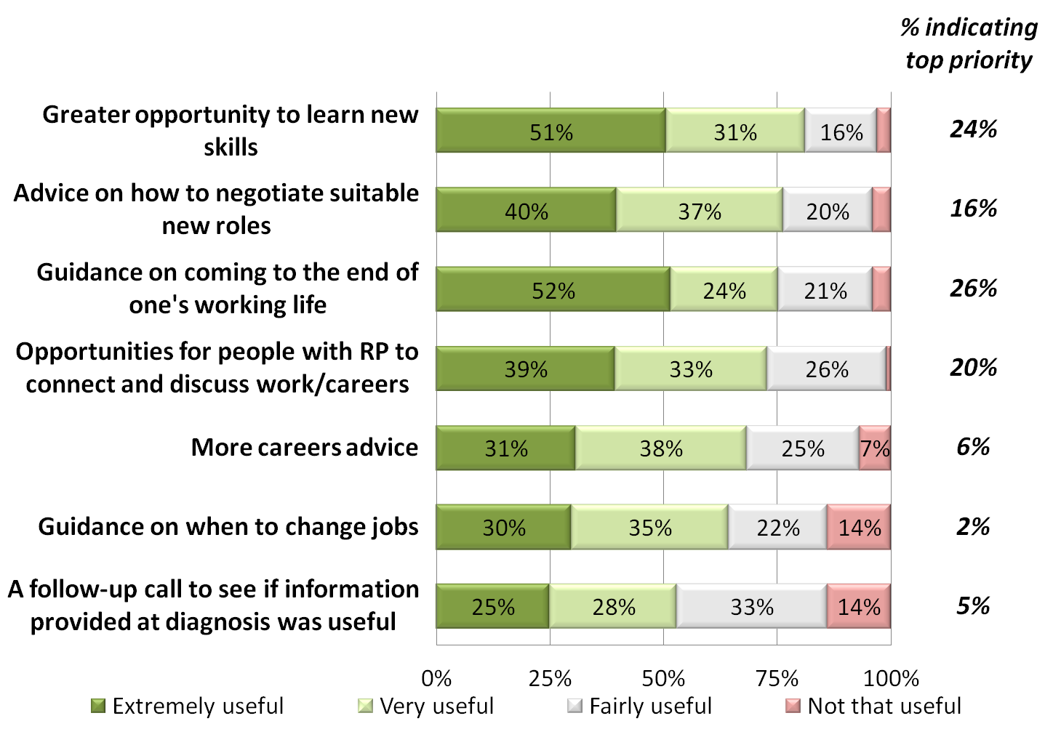

*Figure 6 Q24: Please indicate how useful each of the ideas would be to help people with RP to keep their career moving in the right direction*

The chart indicates that all seven ideas were regarded as either *extremely useful* or *very useful* by more than half of the respondents. Two ideas were seen as either *extremely useful* or *very useful* by around 8 in 10 respondents:

* **Greater opportunity to learn new skills in order to keep pace or move to another job or field** was viewed as *extremely useful* by half and *very useful* by a further 3 in 10
* **Advice on how to negotiate new roles with current employers which are both satisfying and realistic** was regarded as *extremely useful* by 2 in 5 and *very useful* by a further 1 in 5
  + this was particularly appealing to younger respondents (16-44y.), with 9 in 10 seeing this as *extremely* or *very useful*
* In addition, 8 in 10 (83%) of London-based respondents would find **more opportunity for people with RP to connect and discuss work and career matters** as extremely or very useful

However, when asked what the top priority should be for Retina UK to focus on, the most selected item was none of these, but instead **guidance on coming to the end of one’s working life e.g. on early retirement, voluntary redundancy, pension planning**. This was chosen by one quarter of respondents (26%). The next two most popular as top priorities were:

* Greater opportunities to learn new skills in order to keep pace or move to another job or field (24%)
* More opportunity for people with RP to connect and discuss work and career matters e.g. at local events or on an online contact network (20%)
  + this was the top priority most selected by younger respondents (36%) and the self-employed (n=13, 46%)

Given the opportunity, 19 respondents made suggestions on how these ideas could best be put into practice by Retina UK.

(1) **Guidance on coming to the end of one’s working life**

* a number noted that retirement is a sometimes daunting prospect if sight is deteriorating, so any guidance would be welcome

**My biggest fear is not having much of a life when I retire**

**Respondent 57**

(2) **Greater opportunities to learn new skills in order to keep pace or move to another job or field**

* more local opportunities if possible
* one request to be taught Braille
* input from careers advisers suggested

(3) **More opportunity for people with RP to connect and discuss work and career matters**

* social media as well as face to face and online networks suggested

**The online contact network might also support the previous goal of sharing experiences of those already in jobs and could be a project where contributors are users of the website and can share short articles or videos of their experiences. The face-to-face groups are also a good idea too.**

**Respondent 70**

New suggestions were also invited. Of 11 comments received, the only recurrent theme was to reiterate the need for more networking opportunities, for example locally-based or at least accessible to those living outside big cities, providing forums to discuss work but also other issues of living with sight loss.

## Services for Employers

The last area that participants were asked to think about was what help employers could benefit from. An advisory service had been suggested in the qualitative research and there were nine possible areas of advice that we asked respondents to consider.

**Summary of main findings**

* It was recommended that advice provided by Retina UK to employers would be best provided directly with organisations, although online, email and telephone communication were all well supported
* All the suggested nine areas of advice were rated by at least three quarters of respondents as very useful or extremely useful for employers
* **Guidance on *reasonable adjustments*** was seen to be the highest priority for Retina UK to provide for employers, with more than 1 in 5 selecting this (22%)
* this was seen as particularly important for small businesses
* **The importance of open and honest dialogue between employers and staff with RP** was the second highest priority (14%)
* rewarding best practice in employment of people with visual impairment was suggested
* Advice on the **symptoms of RP** and on the **challenges faced in the workplace and what assistive technology is available, why it is useful, and how to encourage its use** were also high priorities (13%)

Firstly, we asked in what format the advice could be provided. Direct work by Retina UK with organisations was thought to be the most useful (43%), and online advice via email or webchat was also highly regarded (31%). This finding was consistent across subgroups.

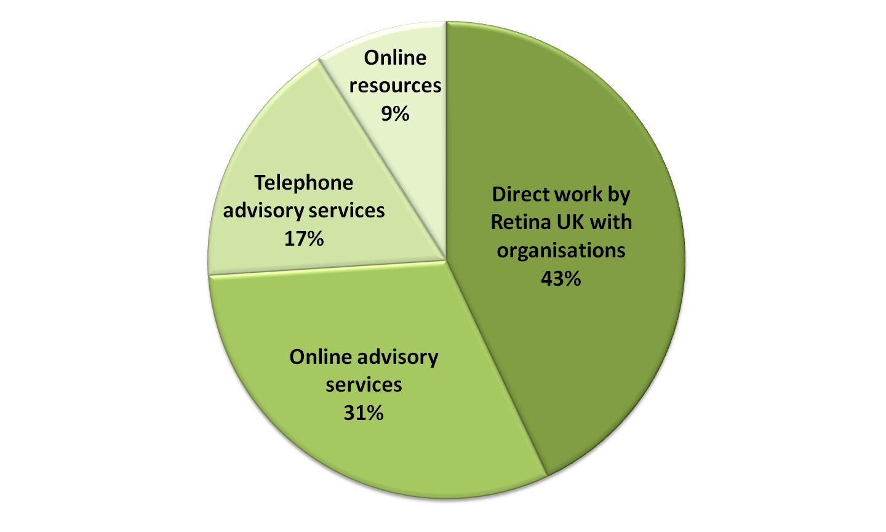

*Figure 7 Q29: Which of the following do you think would be the most useful way to provide this guidance for employers?*

The respondents then said how useful they would find each of nine possible areas of advice.

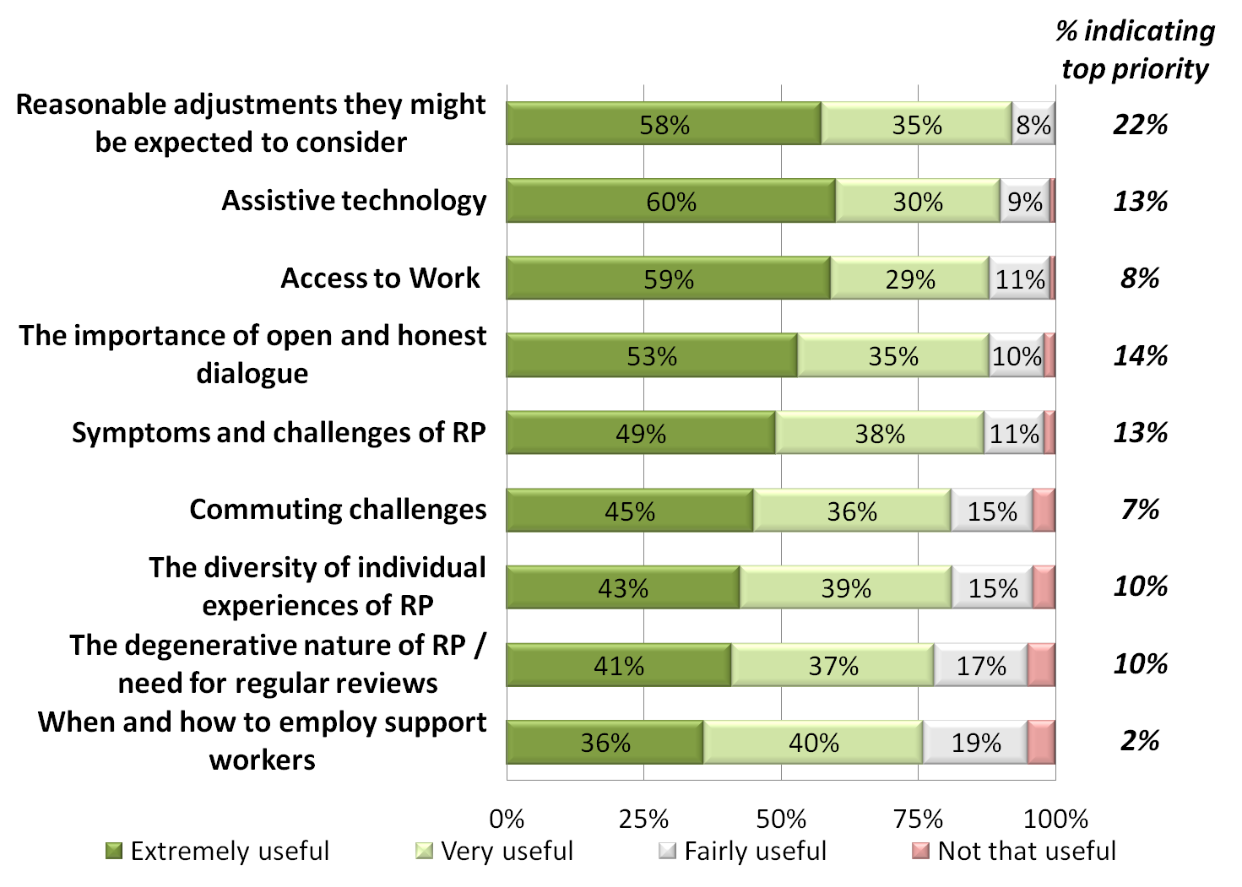

*Figure 8 Q30: Please indicate how useful it would be to raise awareness or understanding amongst employers of the following issues*

The chart indicates that all nine ideas were regarded as either *extremely useful* or *very useful* by at least three quarters of the respondents. Clearly, there is strong support for these sorts of services.

Two ideas were seen as either *extremely useful* or *very useful* by at least 9 in 10 respondents:

* **Guidance on what *reasonable adjustments* an employer might be expected to consider** was viewed as *extremely useful* by nearly 6 in 10 and *very useful* by a further third
* **Assistive technology – what is available, why it is useful and how to encourage its use** was rated as *extremely useful* by 6 in 10 and *very useful* by a further 3 in 10
  + nearly all (96%) of those who have made a career change since diagnosis were significantly more likely to rate this as *very* or *extremely useful*
* In addition, younger respondents thought that advice on **symptoms of RP and challenges faced in the workplace** would be very or extremely useful for employers (95%) and females thought that **addressing and solving commuting challenges** (92%) would be *very* or *extremely useful*

Those who were not working were generally more likely than those in work to rate all areas of advice for employers as *very* or *extremely useful.*

In terms of the top priorities for Retina UK to give attention to, **guidance on *reasonable adjustments*** was much more likely to be selected than other areas (22%). Three other areas were top priority for about 1 in 7:

* The importance of open and honest dialogue between employers and staff with RP (14%)
* Symptoms of RP and challenges faced in the workplace (13%)
* What assistive technology is available, why it is useful, and how to encourage its use (13%)

These were consistent across subgroups.

17 respondents commented when asked for suggestions as to how the ideas could best be put into practice:

(1) **Guidance on reasonable adjustments**

* seen as particularly useful for small businesses
* online resources suggested, as well as a telephone helpline

(2) **The importance of open and honest dialogue between employers and staff with RP**

* reward employers who work hard to accommodate people with visual impairment

**Information could be lost without face to face meeting. The employer is reassured there is RPFB there to go to. Do a scheme where an employer has embraced as much as possible to make them VI Employer of the Year. It will encourage them to work with the employee to gain promotion, help others, raise awareness and help fundraise**

**Respondent 25**

**Open and clear dialogue is the only way individuals can manage their own situation. Each is a unique challenge, no short cuts here. So being straight and showing clearly the positive plus dealing with more challenging without becoming too upset is the aim here. Discouraging employers from assuming all sight impaired people are the same etc.**

**Respondent 68**

(3) **What assistive technology is available, why it is useful, and how to encourage its use**

**Technology is moving quickly, it is our best hope at continuing a normal life but my experience is that I haven't a clue what is available**

**Respondent 60**

## Summing Up

At the end of the questionnaire, respondents were shown all of their top priorities and asked to select the one which they felt was most important of all.

**Summary of main findings**

* Diagnosis was seen to be the most crucial time to get the right information and support
* In particular, help with **information on how one’s RP might develop in order to inform one’s work and career choices** at diagnosis was the most selected top priority of all (10% selected this as their number one priority), followed by **guidance on Access to Work and assistive technology** (7%). Information too on **how to manage possible work or employment difficulties** (4%) was also much sought after
* Tools and advice to help people remain in their job was the second area that people tended to focus on as a priority for Retina UK
* there was clear recommendation for Retina UK to **work with employers and people with RP to facilitate constructive solutions for both parties**, such as adapting the workplace or finding new roles (7%).
* work to **raise awareness and understanding of Access to Work and assistive technology for those in or seeking employment** were also very important (4%)
* **Opportunities to learn new skills** (4%) and to **connect with others with RP to discuss work and career matters** (4%) were also held in very high regard

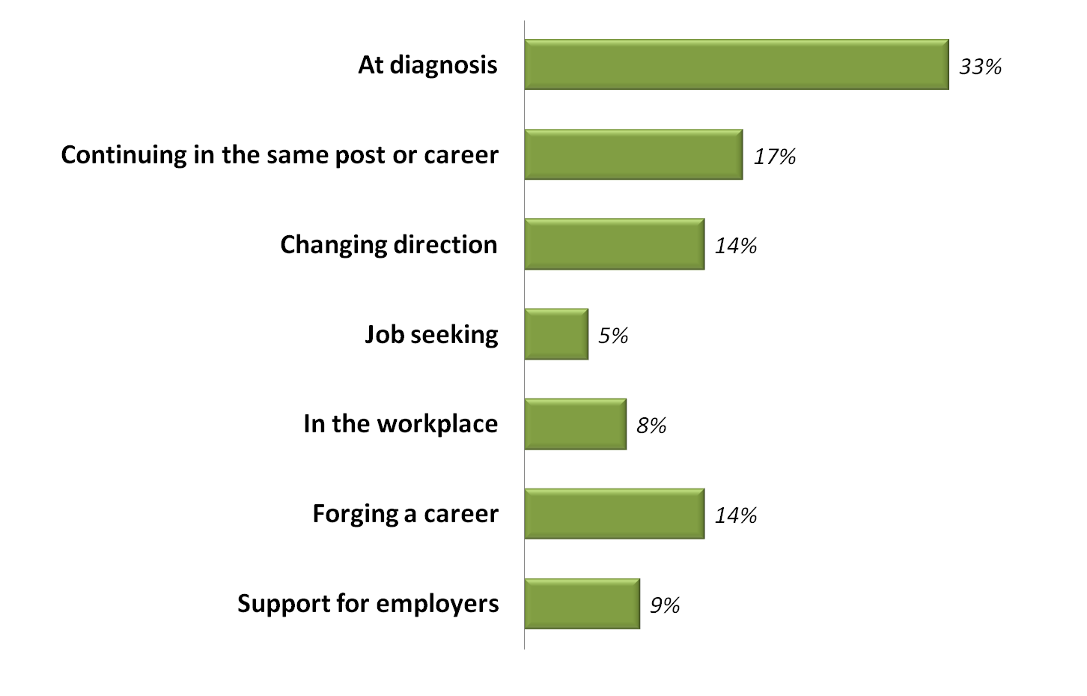

*Figure 9 Q34: Stage at which services should be prioritised*

The chart indicates that people were most keen for more services to be provided at the point of diagnosis (33%), or to help people stay in their existing job (17%).

* younger respondents, however, were more keen on help to forge their career (27%) or to change career path (22%)

**I think that the point of diagnosis has a huge, emotional impact on the individual. Having people to talk to so that one can begin to understand the range of outcomes that may become their reality, and then the possible options open to them, is incredibly important. Staying mentally strong at this point is difficult, but is essential. Offering emotional support and practical support, both in terms of what changes the person may need to make, or the opportunities available to them, as well as how to positively and realistically discuss RP with one's employer, is vital.**

**Respondent 151**

Many people commented that diagnosis is the best time to let people know about their options and any assistance that can be sought. **Information on how one’s RP might develop in order to inform one’s work and career choices** at diagnosis was the most selected top priority of all (10% selected this as their single biggest priority out of everything suggested in the consultation), followed by **guidance on Access to Work and assistive technology** (7%). Information too on **how to manage possible work or employment difficulties** (4%) was also much sought after.

**[Providing guidance at diagnosis] is more of a proactive approach. It encourages the person to think about the future and plan ahead for potential training needs and change of career direction. Many people when they phone the helpline at this point have buried their head in the sand for too many years and it is almost too late for them to make the necessary changes. This is the approach which is most empowering and encourages people to take responsibility for their own future**

**Respondent 2**

**At Diagnosis as this is the beginning of their journey, get it right here and their journey will be brighter- everything else can be communicated throughout their journey.**

**Respondent 27**

In order for people to stay in their existing job, most requested was for Retina UK to **work with employers and people with RP to facilitate constructive solutions for both parties,** such as adapting the workplace or finding new roles (7%). Again, work to **raise awareness and understanding of Access to Work and assistive technology** were also very important (4%).

**Because it all comes down to two aspects: 1. A person with RP wants employment 2. An employer with a job vacancy wants a person to do that job. The most basic and obvious way to achieve these two things is for the person with RP to be open and honest about what they can do and what their limitations are, and for the employer to have all the information they need including the reassurance that a person with RP can still be a very capable member of staff and having RP need not be a hindrance to carrying out job tasks fully.**

**Respondent 37**

**Assistive technology is continually changing and advancing. It is too expensive to buy and find it is not right for you. It can also be overwhelming even though you know something might be out there that can help. Advice from somebody who knows what is out there would be brilliant.**

**Respondent 73**

**If I had had any information about Access to Work, it could have been different. You can’t ask for what you don’t know exists.**

**Respondent 156**

**Opportunities to learn new skills** (4%) and to **connect with others with RP** to discuss work and career matters (4%) were also held in very high regard.

**[Opportunities to learn new skills] is the most empowering option and encompasses many of the other items. The other options also helpful are passive and rely on other people taking action.**

**Respondent 146**

# Appendices

1. Method, Fieldwork and Analysis

2. Questionnaire

3. Data for charts

## Appendix 1: Method, Fieldwork and Analysis

Alpha Research prepared a questionnaire in SNAP for online completion. This was agreed with Retina UK and piloted in August 2018. After some refinements, it was launched in September 2018 by sending out a link to all people on the Retina UK database who had agreed to receive communications from the organization.

Two versions of the questionnaire were prepared, one in standard HTML format and one in plain text. Respondents could choose which one they completed.

The questionnaire was hosted and results collated by Alpha Research. A Word export of the SNAP questionnaire is also appended here.

In total, 171 responses were received – 150 to the standard questionnaire version and 21 to the plain text version.

The breakdown of responses is shown in the table below.

|  |  |
| --- | --- |
| Bases = 156 - 168 |  |
| Aged <35y | 7% |
| Aged 35-54y. | 63% |
| Aged 55y.+ | 30% |
|  |  |
| Male | 53% |
| Female | 47% |
|  |  |
| White British/English/Scottish/Welsh ethnic group | 92% |
| BME | 8% |
|  |  |
| England: London | 13% |
| England: South East/ South West | 31% |
| England: Midlands/ East Anglia | 23% |
| England: North West/ North East/ Humberside | 19% |
| Northern Ireland | <1% |
| Scotland | 10% |
| Wales | 3% |
|  |  |
| In full time work | 49% |
| In part time work | 12% |
| Self-employed | 5% |
| Not working & looking for work | 10% |
| Not working & not looking | 18% |
|  |  |
| Registered as visually impaired | 76% |
| Not registered as visually impaired | 24% |
|  |  |
| Responding as someone with Retinitis Pigmentosa | 93% |
| Responding in another capacity | 7% |

Full statistical tables of the answers given are available.

## 

## Appendix 2: Questionnaire

# 

|  |  |
| --- | --- |
|  | Retina UK Working Age Group Project |

|  |  |
| --- | --- |
|  | Thanks very much for taking part in the Retina UK Working Age Project. This project has been running since 2017 and has been instrumental in furthering understanding of the challenges people with RP face in the workplace; in looking for work and in following careers. |

|  |  |
| --- | --- |
|  | It has given the opportunity for many people to put forward ideas for useful services that could be provided for working age people with RP and those that work with them. So far, in focus groups and online forums, many great suggestions have been made and we would now be very grateful for your help to identify which of these should be prioritised. |

|  |  |
| --- | --- |
|  | Different ideas correspond to different stages of people’s careers and so the questionnaire is divided into the following sections:  1. Diagnosis  2. Continuing in the same post or career  3. Changing direction  4. Finding, applying for and winning jobs  5. In the workplace  6. Forging a career  7. Support for employers |
|  |

|  |  |
| --- | --- |
|  | Diagnosis |

|  |  |
| --- | --- |
|  | Firstly please think about when one is first diagnosed with Retinitis Pigmentosa (RP). What services might be most useful at that point with regard to one's working life? Please could you give your opinion on the following ideas. |

|  |  |  |  |  |  |  |  |  |  |  |  |
| --- | --- | --- | --- | --- | --- | --- | --- | --- | --- | --- | --- |
| Q1 | Please indicate how useful each of the following ideas would be **at the point of diagnosis**  . | | | | | | | | | | |
|  |  | Extremely useful |  | Very useful |  | Fairly useful |  | Not that useful |  | Not sure |  |
|  | More information at diagnosis on how RP might develop, in order to inform one's work and career choices | ❑ |  | ❑ |  | ❑ |  | ❑ |  | ❑ |  |
|  | Guidance at diagnosis on how assistive technology and Access to Work can aid employment and work | ❑ |  | ❑ |  | ❑ |  | ❑ |  | ❑ |  |
|  | Information, advice, leaflets and internet resources at diagnosis about how to manage possible employment or work difficulties that people with RP can face | ❑ |  | ❑ |  | ❑ |  | ❑ |  | ❑ |  |
|  | Being signposted at diagnosis to agencies either locally or nationally that give advice on employment issues | ❑ |  | ❑ |  | ❑ |  | ❑ |  | ❑ |  |
|  | Referral at diagnosis to someone with RP in work, for advice and assistance on retaining and progressing in work | ❑ |  | ❑ |  | ❑ |  | ❑ |  | ❑ |  |
|  | Advice/support at diagnosis which is tailored to children and their parents | ❑ |  | ❑ |  | ❑ |  | ❑ |  | ❑ |  |

|  |  |  |
| --- | --- | --- |
| Q2 | If you had to choose one, which ONE would you recommend that Retina UK prioritises? | |
|  | ❑ | More information at diagnosis on how RP might develop, in order to inform one's work and career choices |
|  | ❑ | Guidance at diagnosis on how assistive technology and Access to Work can aid employment and work |
|  | ❑ | Information, advice, leaflets and internet resources at diagnosis about how to manage possible employment or work difficulties that people with RP can face |
|  | ❑ | Being signposted at diagnosis to agencies either locally or nationally that give advice on employment issues |
|  | ❑ | Referral at diagnosis to someone with RP in work, for advice and assistance on retaining and progressing in work |
|  | ❑ | Advice/support at diagnosis which is tailored to children and their parents |

|  |  |
| --- | --- |
| Q3 | If you have any thoughts on how this idea could best be put into practice, then we would be very grateful for your suggestions here. |
|  | _________________________________________________________________________________ |

|  |  |
| --- | --- |
| Q4 | If you would like to suggest anything else that an agency like Retina UK could provide at the point of diagnosis, then you may do so below. |
|  | _________________________________________________________________________________ |

|  |  |
| --- | --- |
|  | Continuing in the same post or career |

|  |  |  |
| --- | --- | --- |
| Q6 | At the point of diagnosis was your hope to remain in the post you were in? | |
|  | ❑ | Yes |
|  | ❑ | No |
|  | ❑ | Don't know |

|  |  |  |  |  |  |  |  |  |  |  |  |
| --- | --- | --- | --- | --- | --- | --- | --- | --- | --- | --- | --- |
| Q7 | Now I'd like you to think about what might be most useful to help people stay in their post once they have been diagnosed. How would you rate the following in terms of how useful they would be for people at that point? | | | | | | | | | | |
|  |  | Extremely useful |  | Very useful |  | Fairly useful |  | Not that useful |  | Not sure |  |
|  | A sight loss agency like Retina UK raising awareness generally about the challenges faced by those with RP and losing one's sight whilst still working | ❑ |  | ❑ |  | ❑ |  | ❑ |  | ❑ |  |
|  | Advice on how to talk to one's employer about RP | ❑ |  | ❑ |  | ❑ |  | ❑ |  | ❑ |  |
|  | An agency like Retina UK working with employers and people with RP to facilitate constructive solutions for both parties e.g. adapting the workplace or finding new roles | ❑ |  | ❑ |  | ❑ |  | ❑ |  | ❑ |  |
|  | An agency like Retina UK raising awareness of Access to Work, assistive technology and other available support | ❑ |  | ❑ |  | ❑ |  | ❑ |  | ❑ |  |
|  | Employment advice, support and mentoring specialised for people with visual impairment, provided by a sight loss agency like Retina UK | ❑ |  | ❑ |  | ❑ |  | ❑ |  | ❑ |  |
|  | Guidance on RP for *colleagues* of people with RP | ❑ |  | ❑ |  | ❑ |  | ❑ |  | ❑ |  |

|  |  |  |
| --- | --- | --- |
| Q8 | If you had to choose one, which ONE would you recommend that Retina UK prioritises? | |
|  | ❑ | A sight loss agency like Retina UK raising awareness generally about the challenges faced by those with RP and losing one's sight whilst still working |
|  | ❑ | Advice on how to talk to one's employer about RP |
|  | ❑ | An agency like Retina UK working with employers and people with RP to facilitate constructive solutions for both parties e.g. adapting the workplace or finding new roles |
|  | ❑ | An agency like Retina UK raising awareness of Access to Work, assistive technology and other available support |
|  | ❑ | Employment advice, support and mentoring specialised for people with visual impairment, provided by a sight loss agency like Retina UK |
|  | ❑ | Guidance on RP for colleagues of people with RP |

|  |  |
| --- | --- |
| Q9 | If you have any thoughts on how this idea could best be put into practice, then we would be very grateful for your suggestions here. |
|  | _________________________________________________________________________________ |

|  |  |
| --- | --- |
| Q10 | If you would like to suggest anything else that an agency like Retina UK could provide to help people with RP stay in their post once diagnosed with RP, then you may do so below  . |
|  | ________________________________________________________________________________ |

|  |  |
| --- | --- |
|  | Changing direction |

|  |  |
| --- | --- |
|  | This section is about making significant changes in the direction of one's career after diagnosis. You don't necessarily have to have made such a move yet. |

|  |  |  |
| --- | --- | --- |
| Q11 | Have you... | |
|  | ❑ | ...made a career change since being diagnosed with RP? |
|  | ❑ | ...thought about making a career change since being diagnosed with RP? |
|  | ❑ | ...stayed in the same line of work and not considered changing career since being diagnosed with RP? |

|  |  |  |  |  |  |  |  |  |  |  |  |
| --- | --- | --- | --- | --- | --- | --- | --- | --- | --- | --- | --- |
| Q12 | How useful would each of the following be as help to people with RP looking to change career direction? | | | | | | | | | | |
|  |  | Extremely useful |  | Very useful |  | Fairly useful |  | Not that useful |  | Not sure |  |
|  | Information or advice on the jobs people with RP can do e.g. from others at work with RP | ❑ |  | ❑ |  | ❑ |  | ❑ |  | ❑ |  |
|  | Information on what jobs/careers might be difficult or impossible with RP | ❑ |  | ❑ |  | ❑ |  | ❑ |  | ❑ |  |
|  | Career coaching tailored for people with RP | ❑ |  | ❑ |  | ❑ |  | ❑ |  | ❑ |  |
|  | Opportunities to meet employers and demonstrate one's skills e.g. through placements, temporary posts, assessments or careers fairs | ❑ |  | ❑ |  | ❑ |  | ❑ |  | ❑ |  |
|  | Advice on what support is available to learn new skills, retrain or go back into education | ❑ |  | ❑ |  | ❑ |  | ❑ |  | ❑ |  |
|  | Advice on planning a career path when you have a *developing* condition | ❑ |  | ❑ |  | ❑ |  | ❑ |  | ❑ |  |
|  | Reassurance for *potential* employers about employing someone with RP | ❑ |  | ❑ |  | ❑ |  | ❑ |  | ❑ |  |
|  | A database of current jobs available, or training opportunities | ❑ |  | ❑ |  | ❑ |  | ❑ |  | ❑ |  |
|  | A database of people with RP, indicating their areas of expertise, for prospective employers to access | ❑ |  | ❑ |  | ❑ |  | ❑ |  | ❑ |  |

|  |  |  |
| --- | --- | --- |
| Q13 | If you had to choose one, which ONE would you recommend that Retina UK prioritises? | |
|  | ❑ | Information or advice on the jobs people with RP can do e.g. from others at work with RP |
|  | ❑ | Information on what jobs/careers might be difficult or impossible with RP |
|  | ❑ | Career coaching tailored for people with RP |
|  | ❑ | Opportunities to meet employers and demonstrate one's skills e.g. through placements, temporary posts, assessments or careers fairs |
|  | ❑ | Advice on what support is available to learn new skills, retrain or go back into education |
|  | ❑ | Advice on planning a career path when you have a *developing* condition |
|  | ❑ | Reassurance for *potential* employers about employing someone with RP |
|  | ❑ | A database of current jobs available, or training opportunities |
|  | ❑ | A database of people with RP indicating their areas of expertise, for prospective employers to access |

|  |  |
| --- | --- |
| Q14 | If you have any thoughts on how this idea could best be put into practice, then we would be very grateful for your suggestions here. |
|  | _________________________________________________________________________________ |

|  |  |
| --- | --- |
| Q15 | If you would like to suggest anything else that an agency like Retina UK could provide to help people with RP change career direction, then you may do so below. |
|  | _________________________________________________________________________________ |

|  |  |
| --- | --- |
|  | Finding, applying for and winning jobs |

|  |  |
| --- | --- |
|  | This section is about services that people with RP might find useful when applying for jobs. This includes applying for new posts with a current employer (e.g. different roles, promotion), as well as jobs with new employers. |

|  |  |  |  |  |  |  |  |  |  |  |  |
| --- | --- | --- | --- | --- | --- | --- | --- | --- | --- | --- | --- |
| Q16 | Please say how useful the following would be for people with RP when applying for new jobs or posts? | | | | | | | | | | |
|  |  | Extremely useful |  | Very useful |  | Fairly useful |  | Not that useful |  | Not sure |  |
|  | If, when and how to disclose one's condition | ❑ |  | ❑ |  | ❑ |  | ❑ |  | ❑ |  |
|  | How to prepare for an interview e.g. finding out about useful aids for undertaking the work | ❑ |  | ❑ |  | ❑ |  | ❑ |  | ❑ |  |
|  | To raise awareness of potential employers on the practical and financial support available to employ someone with RP | ❑ |  | ❑ |  | ❑ |  | ❑ |  | ❑ |  |
|  | Advice on the pros and cons of registering as visually impaired | ❑ |  | ❑ |  | ❑ |  | ❑ |  | ❑ |  |
|  | Indication from Access to Work at the point of applying for a job on what assistance might be funded | ❑ |  | ❑ |  | ❑ |  | ❑ |  | ❑ |  |
|  | Online training manuals to teach people how to navigate the job market, job applications, interviews and selection processes | ❑ |  | ❑ |  | ❑ |  | ❑ |  | ❑ |  |

|  |  |  |
| --- | --- | --- |
| Q17 | If you had to choose one, which ONE would you recommend that Retina UK prioritises? | |
|  | ❑ | If, when and how to disclose one's condition |
|  | ❑ | How to prepare for an interview e.g. finding out about useful aids for undertaking the work |
|  | ❑ | To raise awareness of potential employers on the practical and financial support available to employ someone with RP |
|  | ❑ | Advice on the pros and cons of registering as visually impaired |
|  | ❑ | Indication from Access to Work at the point of applying for a job on what assistance might be funded |
|  | ❑ | Online training manuals to teach people how to navigate the job market, job applications, interviews and selection processes |

|  |  |
| --- | --- |
| Q18 | If you have any thoughts on how this idea could best be put into practice, then we would be very grateful for your suggestions here. |
|  | _________________________________________________________________________________ |

|  |  |
| --- | --- |
| Q19 | If you would like to suggest anything else that an agency like Retina UK could provide to help people when applying for jobs, then you may do so below. |
|  | _________________________________________________________________________________ |

|  |  |
| --- | --- |
|  | In the workplace |

|  |  |
| --- | --- |
|  | Now please look at some ideas that have been suggested as useful for people with RP in the workplace, in their existing job. |

|  |  |  |  |  |  |  |  |  |  |  |  |
| --- | --- | --- | --- | --- | --- | --- | --- | --- | --- | --- | --- |
| Q20 | How useful would the following be? | | | | | | | | | | |
|  |  | Extremely useful |  | Very useful |  | Fairly useful |  | Not that useful |  | Not sure |  |
|  | Advice on whether to disclose RP in order to gain access to technology and funding etc. | ❑ |  | ❑ |  | ❑ |  | ❑ |  | ❑ |  |
|  | Advice on how to explain to an employer what you might be needing as your RP develops | ❑ |  | ❑ |  | ❑ |  | ❑ |  | ❑ |  |
|  | Advice on how to be more effective at work e.g. ideas for efficiencies | ❑ |  | ❑ |  | ❑ |  | ❑ |  | ❑ |  |
|  | Advice on technology and assistive technology | ❑ |  | ❑ |  | ❑ |  | ❑ |  | ❑ |  |
|  | Information on how Access to Work works, what it can fund, and how to apply successfully | ❑ |  | ❑ |  | ❑ |  | ❑ |  | ❑ |  |
|  | Lobbying to encourage faster administration of Access to Work | ❑ |  | ❑ |  | ❑ |  | ❑ |  | ❑ |  |
|  | Access to Work assessments outside of normal office hours e.g. for shift workers | ❑ |  | ❑ |  | ❑ |  | ❑ |  | ❑ |  |
|  | Help with finding and vetting support workers via Access to Work | ❑ |  | ❑ |  | ❑ |  | ❑ |  | ❑ |  |

|  |  |  |
| --- | --- | --- |
| Q21 | If you had to choose one, which ONE would you recommend that Retina UK prioritises? | |
|  | ❑ | Advice on whether to disclose RP in order to gain access to technology and funding etc. |
|  | ❑ | Advice on how to explain to an employer what you might be needing as your RP develops |
|  | ❑ | Advice on how to be more effective at work e.g. ideas for efficiencies or useful technology |
|  | ❑ | Advice on technology and assistive technology |
|  | ❑ | Information on how Access to Work works, what it can fund, and how to apply successfully |
|  | ❑ | Lobbying to encourage faster administration of Access to Work |
|  | ❑ | Access to Work assessments outside of normal office hours e.g. for shift workers |
|  | ❑ | Help with finding and vetting support workers via Access to Work |

|  |  |
| --- | --- |
| Q22 | If you have any thoughts on how this idea could best be put into practice, then we would be very grateful for your suggestions here. |
|  | ________________________________________________________________________________ |

|  |  |
| --- | --- |
| Q23 | If you would like to suggest anything else that an agency like Retina UK could provide to help people in their current job, then you may do so below. |
|  | _________________________________________________________________________________ |

|  |  |
| --- | --- |
|  | Forging a career |

|  |  |
| --- | --- |
|  | Now please think about progressing a career and what more you think people with RP need to keep their career moving in the right direction. |

|  |  |  |  |  |  |  |  |  |  |  |  |
| --- | --- | --- | --- | --- | --- | --- | --- | --- | --- | --- | --- |
| Q24 | Please indicate how useful the following would be for people with RP... | | | | | | | | | | |
|  |  | Extremely useful |  | Very useful |  | Fairly useful |  | Not that useful |  | Not sure |  |
|  | More careers advice e.g. via telephone advice line run by a sightloss agency like Retina UK | ❑ |  | ❑ |  | ❑ |  | ❑ |  | ❑ |  |
|  | More opportunity for people with RP to connect and discuss work and career matters e.g. at local events or on an online contact network | ❑ |  | ❑ |  | ❑ |  | ❑ |  | ❑ |  |
|  | Greater opportunity to learn new skills in order to keep pace or move to another job or field | ❑ |  | ❑ |  | ❑ |  | ❑ |  | ❑ |  |
|  | Guidance on coming to the end of one's working life e.g. on early retirement, voluntary redundancy, pension planning | ❑ |  | ❑ |  | ❑ |  | ❑ |  | ❑ |  |
|  | Advice on how to negotiate new roles with current employers which are both satisfying and realistic | ❑ |  | ❑ |  | ❑ |  | ❑ |  | ❑ |  |
|  | A follow-up call (or periodic e.g. yearly calls) to see if the work information provided at diagnosis has been useful | ❑ |  | ❑ |  | ❑ |  | ❑ |  | ❑ |  |
|  | Guidance on when to change jobs | ❑ |  | ❑ |  | ❑ |  | ❑ |  | ❑ |  |

|  |  |  |
| --- | --- | --- |
| Q25 | If you had to choose one, which ONE would you recommend that Retina UK prioritises? | |
|  | ❑ | More careers advice e.g. via telephone advice line run by a sightloss agency like Retina UK |
|  | ❑ | More opportunity for people with RP to connect and discuss work and career matters e.g. at local events or on an online contact network |
|  | ❑ | Greater opportunity to learn new skills in order to keep pace or move to another job or field |
|  | ❑ | Guidance on coming to the end of one's working life e.g. on early retirement, voluntary redundancy, pension planning |
|  | ❑ | Advice on how to negotiate new roles with current employers which are both satisfying and realistic |
|  | ❑ | A follow-up call (or periodic e.g. yearly calls) to see if the work information provided at diagnosis has been useful |
|  | ❑ | Guidance on when to change jobs |

|  |  |
| --- | --- |
| Q26 | If you have any thoughts on how this idea could best be put into practice, then we would be very grateful for your suggestions here. |
|  | ________________________________________________________________________________ |

|  |  |
| --- | --- |
| Q27 | If you would like to suggest anything else that an agency like Retina UK could provide to help people progress their career, then you may do so below. |
|  | _________________________________________________________________________________ |

|  |  |
| --- | --- |
|  | Support for employers |

|  |  |
| --- | --- |
|  | The last area to think about is what help you think an agency like Retina UK could provide for employers of people with RP. |

|  |  |  |
| --- | --- | --- |
| Q29 | Firstly there was the suggestion that an advisory service could be provided, in one of a number of formats. Which of the following do you think would be the most useful way to provide this guidance for employers? | |
|  | ❑ | Telephone advice service |
|  | ❑ | Online advice service e.g. email, webchat/livechat |
|  | ❑ | Online resources e.g. YouTube video tutorials on specific issues |
|  | ❑ | Direct work by Retina UK with HR or occupational health departments e.g. by giving talks or providing tailored information |

|  |  |  |  |  |  |  |  |  |  |  |  |
| --- | --- | --- | --- | --- | --- | --- | --- | --- | --- | --- | --- |
| Q30 | And if Retina UK provides a new advice service for employers in one or more of these ways, how useful would it be to raise awareness or understanding amongst employers of the following issues? | | | | | | | | | | |
|  |  | Extremely useful |  | Very useful |  | Fairly useful |  | Not that useful |  | Not sure |  |
|  | **Symptoms** of RP and challenges faced in the workplace | ❑ |  | ❑ |  | ❑ |  | ❑ |  | ❑ |  |
|  | The **diversity** of individual experiences of RP | ❑ |  | ❑ |  | ❑ |  | ❑ |  | ❑ |  |
|  | The **degenerative** nature of the condition and consequent need for regular reviews | ❑ |  | ❑ |  | ❑ |  | ❑ |  | ❑ |  |
|  | The importance of open and honest **dialogue** between employers and staff with RP | ❑ |  | ❑ |  | ❑ |  | ❑ |  | ❑ |  |
|  | Guidance on what **reasonable adjustments** an employer might be expected to consider | ❑ |  | ❑ |  | ❑ |  | ❑ |  | ❑ |  |
|  | **Assistive technology** - what is available, why it is useful and how to encourage its use | ❑ |  | ❑ |  | ❑ |  | ❑ |  | ❑ |  |
|  | **Access to Work** - how the scheme works and what it can fund | ❑ |  | ❑ |  | ❑ |  | ❑ |  | ❑ |  |
|  | When and how to employ **support workers** | ❑ |  | ❑ |  | ❑ |  | ❑ |  | ❑ |  |
|  | Addressing and solving **commuting challenges** | ❑ |  | ❑ |  | ❑ |  | ❑ |  | ❑ |  |

|  |  |  |
| --- | --- | --- |
| Q31 | If you had to choose one, which ONE would you recommend that Retina UK prioritises? | |
|  | ❑ | **Symptoms** of RP and challenges faced in the workplace |
|  | ❑ | The **diversity** of individual experiences of RP |
|  | ❑ | The **degenerative** nature of the condition and consequent need for regular reviews |
|  | ❑ | The importance of open and honest **dialogue** between employers and staff with RP |
|  | ❑ | Guidance on what **reasonable adjustments** an employer might be expected to consider |
|  | ❑ | **Assistive technology** - what is available, why it is useful and how to encourage its use |
|  | ❑ | **Access to Work** - how the scheme works and what it can fund |
|  | ❑ | When and how to employ **support workers** |
|  | ❑ | Addressing and solving **commuting challenges** |

|  |  |
| --- | --- |
| Q32 | If you have any thoughts on how this idea could best be put into practice, then we would be very grateful for your suggestions here. |
|  | _________________________________________________________________________________ |

|  |  |
| --- | --- |
| Q33 | If you would like to suggest anything else that an agency like Retina UK could provide for employers of people with RP, then you may do so below. |
|  | _________________________________________________________________________________ |

|  |  |
| --- | --- |
|  | Summing up |

|  |  |
| --- | --- |
|  | Below is a list of the one service in each area that you said you would most like to see Retina UK provide. |

|  |  |  |
| --- | --- | --- |
| Q34 | As a final summary, if you had to choose just one of these services, which one would it be? | |
|  | ❑ | *At diagnosis:* More information at diagnosis on how RP might develop, in order to inform one's work and career choices |
|  | ❑ | *At diagnosis:* Guidance at diagnosis on how assistive technology and Access to Work can aid employment and work |
|  | ❑ | *At diagnosis:* Information, advice, leaflets and internet resources at diagnosis about how to manage possible employment or work difficulties that people with RP can face |
|  | ❑ | *At diagnosis:* Being signposted at diagnosis to agencies either locally or nationally that give advice on employment issues |
|  | ❑ | *At diagnosis:* Referral at diagnosis to someone with RP in work, for advice and assistance on retaining and progressing in work |
|  | ❑ | *At diagnosis:* Advice/support at diagnosis which is tailored to children and their parents |
|  | ❑ | *Continuing in the same post or career:* A sight loss agency like Retina UK raising awareness generally about the challenges faced by those with RP and losing one's sight whilst still working |
|  | ❑ | *Continuing in the same post or career:* Advice on how to talk to one's employer about RP |
|  | ❑ | *Continuing in the same post or career:* An agency like Retina UK working with employers and people with RP to facilitate constructive solutions for both parties e.g. adapting the workplace or finding new roles |
|  | ❑ | *Continuing in the same post or career:* An agency like Retina UK raising awareness of Access to Work, assistive technology and other available support |
|  | ❑ | *Continuing in the same post or career:* Employment advice, support and mentoring specialised for people with visual impairment, provided by a sight loss agency like Retina UK |
|  | ❑ | *Continuing in the same post or career:* Guidance on RP for colleagues of people with RP |
|  | ❑ | *Changing direction:* Information or advice on the jobs people with RP can do e.g. from others at work with RP |
|  | ❑ | *Changing direction:* Information on what jobs/careers might be difficult or impossible with RP |
|  | ❑ | *Changing direction:* Career coaching tailored for people with RP |
|  | ❑ | *Changing direction:* Opportunities to meet employers and demonstrate one's skills e.g. through placements, temporary posts, assessments or careers fairs |
|  | ❑ | *Changing direction:* Advice on what support is available to learn new skills, retrain or go back into education |
|  | ❑ | *Changing direction:* Advice on planning a career path when you have a *developing* condition |
|  | ❑ | *Changing direction:* Reassurance for *potential* employers about employing someone with RP |
|  | ❑ | *Changing direction:* A database of current jobs available, or training opportunities |
|  | ❑ | *Changing direction:* A database of people with RP indicating their areas of expertise, for prospective employers to access |
|  | ❑ | *Finding, applying for and winning jobs:* If, when and how to disclose one's condition |
|  | ❑ | *Finding, applying for and winning jobs:* How to prepare for an interview e.g. finding out about useful aids for undertaking the work |
|  | ❑ | *Finding, applying for and winning jobs:* To raise awareness of potential employers on the practical and financial support available to employ someone with RP |
|  | ❑ | *Finding, applying for and winning jobs:* Advice on the pros and cons of registering as visually impaired |
|  | ❑ | *Finding, applying for and winning jobs:* Indication from Access to Work at the point of applying for a job on what assistance might be funded |
|  | ❑ | *Finding, applying for and winning jobs:* Online training manuals to teach people how to navigate the job market, job applications, interviews and selection processes |
|  | ❑ | *In the workplace:* Advice on whether to disclose RP in order to gain access to technology and funding etc. |
|  | ❑ | *In the workplace:* Advice on how to explain to an employer what you might be needing as your RP develops |
|  | ❑ | *In the workplace:* Advice on how to be more effective at work e.g. ideas for efficiencies or useful technology |
|  | ❑ | *In the workplace:* Advice on technology and assistive technology |
|  | ❑ | *In the workplace:* Information on how Access to Work works, what it can fund, and how to apply successfully |
|  | ❑ | *In the workplace:* Lobbying to encourage faster administration of Access to Work |
|  | ❑ | *In the workplace:* Access to Work assessments outside of normal office hours e.g. for shift workers |
|  | ❑ | *In the workplace:* Help with finding and vetting support workers via Access to Work |
|  | ❑ | *Forging a career:* More careers advice e.g. via telephone advice line run by a sightloss agency like Retina UK |
|  | ❑ | *Forging a career:* More opportunity for people with RP to connect and discuss work and career matters e.g. at local events or on an online contact network |
|  | ❑ | *Forging a career:* Greater opportunity to learn new skills in order to keep pace or move to another job or field |
|  | ❑ | *Forging a career:* Guidance on coming to the end of one's working life e.g. on early retirement, voluntary redundancy, pension planning |
|  | ❑ | *Forging a career:* Advice on how to negotiate new roles with current employers which are both satisfying and realistic |
|  | ❑ | *Forging a career:* A follow-up call (or periodic e.g. yearly calls) to see if the work information provided at diagnosis has been useful |
|  | ❑ | *Forging a career:* Guidance on when to change jobs |
|  | ❑ | *Support for employers:* **Symptoms** of RP and challenges faced in the workplace |
|  | ❑ | *Support for employers:* The **diversity** of individual experiences of RP |
|  | ❑ | *Support for employers:* The **degenerative** nature of the condition and consequent need for regular reviews |
|  | ❑ | *Support for employers:* The importance of open and honest **dialogue** between employers and staff with RP |
|  | ❑ | *Support for employers:* Guidance on what **reasonable adjustments** an employer might be expected to consider |
|  | ❑ | *Support for employers:* **Assistive technology** - what is available, why it is useful and how to encourage its use |
|  | ❑ | *Support for employers:* **Access to Work** - how the scheme works and what it can fund |
|  | ❑ | *Support for employers:* When and how to employ **support workers** |
|  | ❑ | *Support for employers:* Addressing and solving **commuting challenges** |

|  |  |
| --- | --- |
| Q35 | Why do you say that? |
|  | _________________________________________________________________________________ |

|  |  |
| --- | --- |
| Q36 | Do you have any final comments or recommendations you would like to add |
|  | _________________________________________________________________________________ |

|  |  |
| --- | --- |
|  | About you |

|  |  |
| --- | --- |
|  | Many thanks for taking part in this survey. Finally we have a few questions about you, so that we can see how the views and needs of different groups of people differ. As this is an anonymous survey these details are totally confidential. |

|  |  |  |
| --- | --- | --- |
| Q37 | Your age | |
|  | ❑ | 16-24 |
|  | ❑ | 25-34 |
|  | ❑ | 35-44 |
|  | ❑ | 45-54 |
|  | ❑ | 55-64 |
|  | ❑ | 65 or over |
|  | ❑ | Prefer not to answer |

|  |  |  |
| --- | --- | --- |
| Q38 | Gender | |
|  | ❑ | Male |
|  | ❑ | Female |
|  | ❑ | Other |
|  | ❑ | Prefer not to answer |

|  |  |  |
| --- | --- | --- |
| Q39 | Region | |
|  | ❑ | Wales |
|  | ❑ | Scotland |
|  | ❑ | Northern Ireland |
|  | ❑ | London |
|  | ❑ | South East England (excl London) |
|  | ❑ | South West England |
|  | ❑ | East Midlands / East Anglia |
|  | ❑ | West Midlands |
|  | ❑ | North West England |
|  | ❑ | North East England |
|  | ❑ | Prefer not to answer |

|  |  |  |
| --- | --- | --- |
| Q40 | Ethnic group | |
|  | ❑ | White |
|  | ❑ | Mixed / multiple ethnic groups |
|  | ❑ | Asian / Asian British |
|  | ❑ | Black / African / Caribbean / Black British |
|  | ❑ | Other ethnic group |
|  | ❑ | Prefer not to answer |

|  |  |  |
| --- | --- | --- |
| Q41 | Which of the following best describes you? | |
|  | ❑ | A full-time employee |
|  | ❑ | A part-time employee |
|  | ❑ | Full-time self-employed/business owner/partner |
|  | ❑ | Part-time self-employed/business owner/partner |
|  | ❑ | Not currently working - looking for work |
|  | ❑ | Not currently working - not looking for work |
|  | ❑ | Retired |
|  | ❑ | Other |
|  | ❑ | Prefer not to answer |
|  | Please specify | |
|  | _________________________________________________________________________________ | |

|  |  |  |
| --- | --- | --- |
| Q42 | Are you registered as visually impaired? | |
|  | ❑ | Yes |
|  | ❑ | No |
|  | ❑ | Prefer not to answer |

|  |  |  |
| --- | --- | --- |
| Q43 | In what capacity have you completed this survey? | |
|  | ❑ | I have RP |
|  | ❑ | I am the relative/carer of someone with RP |
|  | ❑ | I employ someone with RP |
|  | ❑ | I am the colleague of someone with RP |
|  | ❑ | I am the support worker of someone with RP |
|  | ❑ | Other |
|  | ❑ | Prefer not to answer |
|  | Please specify | |

## Appendix 3: Data for charts

*Figure 1. Q1: Please indicate how useful each of the ideas would be at the point of diagnosis*

|  |  |  |  |  |
| --- | --- | --- | --- | --- |
|  | Extremely useful | Very useful | Fairly useful | Not that useful |
| Referral to someone with RP in work for advice and assistance | 37% | 34% | 20% | 9% |
| Signposting to agencies that give advice on employment issues | 42% | 35% | 16% | 7% |
| Information, advice, leaflets and internet resources about managing employment/work difficulties | 46% | 31% | 16% | 7% |
| Advice/support tailored to children and parents | 47% | 31% | 13% | 10% |
| Guidance on assistive technology and Access to Work | 50% | 31% | 11% | 8% |
| More information on how RP might develop | 55% | 31% | 10% | 4% |

## 

*Figure 2. Q6: Please indicate how useful each of the ideas would be to help people stay in their post once they have been diagnosed*

|  |  |  |  |  |
| --- | --- | --- | --- | --- |
|  | Extremely useful | Very useful | Fairly useful | Not that useful |
| Guidance on RP for colleagues of people with RP | 35% | 30% | 27% | 8% |
| Raising awareness of the challenges faced by those with RP | 42% | 33% | 21% | 4% |
| Advice on how to talk to an employer about RP | 48% | 27% | 18% | 6% |
| Facilitating constructive solutions for employers and people with RP | 52% | 35% | 11% | 3% |
| Raising awareness of Access to Work, assistive technology and other available support | 58% | 30% | 12% | 1% |
| Employment advice, support and mentoring by a sight loss agency | 55% | 35% | 9% | 1% |

*Figure 3. Q12: Please indicate how useful each of the ideas would be to help people with RP looking to change career direction*

|  |  |  |  |  |
| --- | --- | --- | --- | --- |
|  | Extremely useful | Very useful | Fairly useful | Not that useful |
| Database of people with RP for prospective employers to access | 31% | 26% | 26% | 16% |
| Information on jobs/careers that might be difficult or impossible | 40% | 23% | 20% | 17% |
| Opportunities to meet employers | 34% | 39% | 19% | 9% |
| Database of jobs available/ training opportunities | 49% | 27% | 19% | 8% |
| Reassurance for potential employers | 50% | 27% | 18% | 6% |
| Information/advice on the jobs people with RP can do | 51% | 26% | 21% | 2% |
| Tailored career coaching | 50% | 31% | 17% | 2% |
| Advice on planning a career path | 59% | 25% | 12% | 4% |
| Advice on support available to learn new skills, retrain etc. | 63% | 25% | 11% | 1% |

*Figure 4. Q16: Please indicate how useful each of the ideas would be to help people with RP when applying for new jobs or posts*

|  |  |  |  |  |
| --- | --- | --- | --- | --- |
|  | Extremely useful | Very useful | Fairly useful | Not that useful |
| Online training manuals on navigating the job market, applications, interviews etc. | 28% | 28% | 32% | 13% |
| How to prepare for an interview | 34% | 38% | 21% | 7% |
| Potential employers made more aware of the practical/financial support available to them | 46% | 36% | 13% | 5% |
| Indication of likely funded assistance from Access to Work | 56% | 26% | 15% | 3% |
| If, when and how to disclose one's condition | 54% | 29% | 9% | 7% |

*Figure 5. Q20: Please indicate how useful each of the ideas would be to help people with RP in the workplace, in their existing job*

|  |  |  |  |  |
| --- | --- | --- | --- | --- |
|  | Extremely useful | Very useful | Fairly useful | Not that useful |
| Access to Work assessments outside normal office hours | 30% | 27% | 28% | 15% |
| Lobbying to encourage faster administration of Access to Work | 38% | 29% | 24% | 10% |
| Help with finding and vetting support workers via Access to Work | 36% | 31% | 24% | 9% |
| Advice on how to be more effective at work | 36% | 32% | 25% | 7% |
| Advice on whether to disclose RP to access to technology, funding etc | 47% | 31% | 18% | 4% |
| Advice on explaining what you might need as RP develops | 51% | 27% | 15% | 7% |
| Advice on technology and assistive technology | 54% | 30% | 13% | 1% |
| Information on Access to Work | 55% | 31% | 10% | 4% |

*Figure 6 Q24: Please indicate how useful each of the ideas would be to help people with RP to keep their career moving in the right direction*

|  |  |  |  |  |
| --- | --- | --- | --- | --- |
|  | Extremely useful | Very useful | Fairly useful | Not that useful |
| A follow-up call to see if information provided at diagnosis was useful | 25% | 28% | 33% | 14% |
| Guidance on when to change jobs | 30% | 35% | 22% | 14% |
| More careers advice | 31% | 38% | 25% | 7% |
| Opportunities for people with RP to connect and discuss work/careers | 39% | 33% | 26% | 1% |
| Guidance on coming to the end of one's working life | 52% | 24% | 21% | 4% |
| Advice on how to negotiate suitable new roles | 40% | 37% | 20% | 4% |
| Greater opportunity to learn new skills | 51% | 31% | 16% | 3% |

*Figure 7 Q29: Which of the following do you think would be the most useful way to provide this guidance for employers?*

|  |  |
| --- | --- |
| Direct work by Retina UK with organisations | 43% |
| Online advisory services | 31% |
| Telephone advisory services | 17% |
| Online resources | 9% |
| Strongly disagree | 0% |
| Don't know | 1% |

*Figure 8 Q30: Please indicate how useful it would be to raise awareness or understanding amongst employers of the following issues*

|  |  |  |  |  |
| --- | --- | --- | --- | --- |
|  | Extremely useful | Very useful | Fairly useful | Not that useful |
| When and how to employ support workers | 36% | 40% | 19% | 5% |
| The degenerative nature of RP / need for regular reviews | 41% | 37% | 17% | 5% |
| The diversity of individual experiences of RP | 43% | 39% | 15% | 4% |
| Commuting challenges | 45% | 36% | 15% | 4% |
| Symptoms and challenges of RP | 49% | 38% | 11% | 2% |
| The importance of open and honest dialogue | 53% | 35% | 10% | 2% |
| Access to Work | 59% | 29% | 11% | 1% |
| Assistive technology | 60% | 30% | 9% | 1% |
| Reasonable adjustments they might be expected to consider | 58% | 35% | 8% | 0% |

*Figure 9 Q34: Stage at which services should be prioritised*

|  |  |
| --- | --- |
| Support for employers | 9% |
| Forging a career | 14% |
| In the workplace | 8% |
| Job seeking | 5% |
| Changing direction | 14% |
| Continuing in the same post or career | 17% |
| At diagnosis | 33% |